Diana Gonzalez Santillan dgonza27
Math 115- Graph Theory
Homework 1, due Jan 11 2916

Q1. Write down an explicit isomorphism between the pentagram and the pentagon graphs.

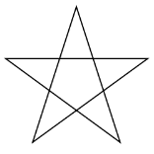Penragram 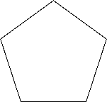Pentagon

Both the pentagram and the pentagon have 5 edges and 5 vertices, all the vertices for both graphs are of degree 2 (both graphs are 2-regular), and adjacency is preserved (all 5 vertices are connected).

Q2. Prove or disprove: up to isomorphism, there is only one
2-regular graph on 5 vertices.

For a graph to be 2-regular, it has to have at least 3 vertices. Considering that, if we take 3 vertices from the 5 vertices available and make them 2-regular, we are left with two other vertices that cannot be 2-regular by themselves:
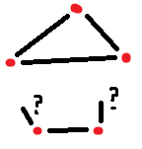

Similarly, if we take 4 vertices and make them 2-regular, we are left with 1 vertex that cannot be 2-regular by itself:
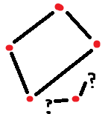

Hence the only way of getting a 2-regular graph on 5 vertices is to join all 5 of them in a cycle, such as the one in question 1.

Q3. Prove or disprove: up to isomorphism, there is only one
2-regular graph on 6 vertices.

Disprove: These two graphs are not isomorphic because they do not preserve adjacency, but they are still both 2-regular on 6 vertices.
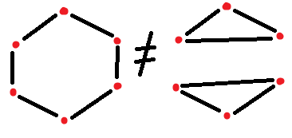

Q4. Now add the adjective “connected” for the graphs of problems 2 and 3. Does this change the answers? How?

2. The only possible 2-regular graph on 5 vertices is a pentagon cycle. If it is a cycle it means it is connected, so the answer wouldn’t change- there is still only one 2-regular connected graph on 5 vertices.
3. In this case the answer would change. The only way we can have a 2-regular graph on 6 vertices that is NOT isomorphic to the hexagon is to have a non-connected graph (two triangles), otherwise, there is only ONE 2-regular connected graph on 6 vertices.

Q5. Formulate analogues of problems 1, 2, 3, and 4 for n vertices. Discuss how the answers change depending on the parity of n.

2-regular graphs on n vertices:
n = 1, 2 – no 2-regular graphs exist
n = 3, 4, 5 – one 2-regular, connected graph exists
n >= 6 – only one 2-regular, connected graph exists, BUT there also exist other 2-regular, non-connected graphs.

Q6. Draw a 3-regular graph on…

4 vertices:
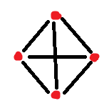
6 vertices:
* Q7. Prove or disprove: there is 3-regular graph on 5 vertices.

For a graph to be 3-regular on 5 vertices, the degree of each vertex must be 3.
So the sum of the degrees must be 5 vertices * degree 3 = 15.

According to the textbook mentioned in class,
2*(number of edges) = sum of degrees.
In this case, 2*(# edges) = 15,
So # edges = 15/2 = 7.5

A graph cannot have a non-integer number of edges such as 7.5, so there is NO way for there to be a 3-regular graph on 5 vertices.

* Q8. Draw all possible labelled trees on…
3 vertices:
3¹ = 3 different graphs:
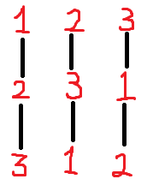

4 vertices:
4² = 16 different graphs:

4 graphs of the form:
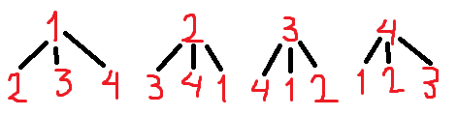

AND 4!/2 = 24/2 = 12 graphs of the form: 1 — 2 — 3 — 4

To figure out which combinations of the labels form those 12 valid graphs I did a probability tree with all the possible outcomes, and then crossed out the ones that were just the same thing but backwards (i.e. crossed 4 — 3 — 2 — 1 because 1 — 2 — 3 — 4 was already there):

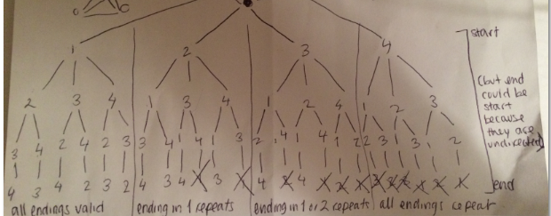

5 vertices:
5³ = 125 different graphs:

5 graphs of the form:
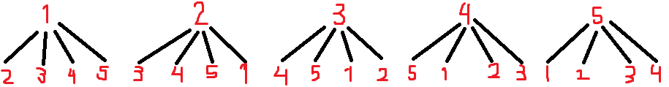

And, following the same logic as for 4 vertices, 5!/2 = 120/2 = 60 graphs of the form: 1 — 2 — 3 — 4 — 5

And 60 other graphs of the form: 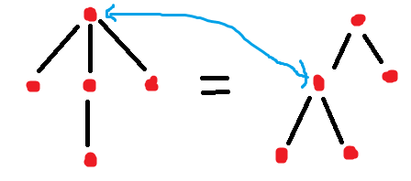
There are 5 options for the top vertex (degree 3), and 4 options for the bottom vertex (degree 1), which can be adhered to any of the three remaining vertices (degree 2 or 1).
5 * 4 * 3 = 60.
5 + 60 + 60 = 125

