EART120 – Coastal practice section Name: _______________________
Real stratigraphic sections often only have sparse sedimentary structures compared to the schematic sections you’ve been working on, making interpretation more challenging. Some portions of the section have relatively unambiguous interpretations, but others could be almost anything when considered in isolation. In order to decipher those ambiguous parts of the section, you typically need to make an argument for the best succession of environments necessary to bridge the gaps between the more clear-cut portions. This exercise uses a real stratigraphic section, so you get to further hone your intuition and reasoning, as well as practicing embracing the ambiguity and uncertainty!

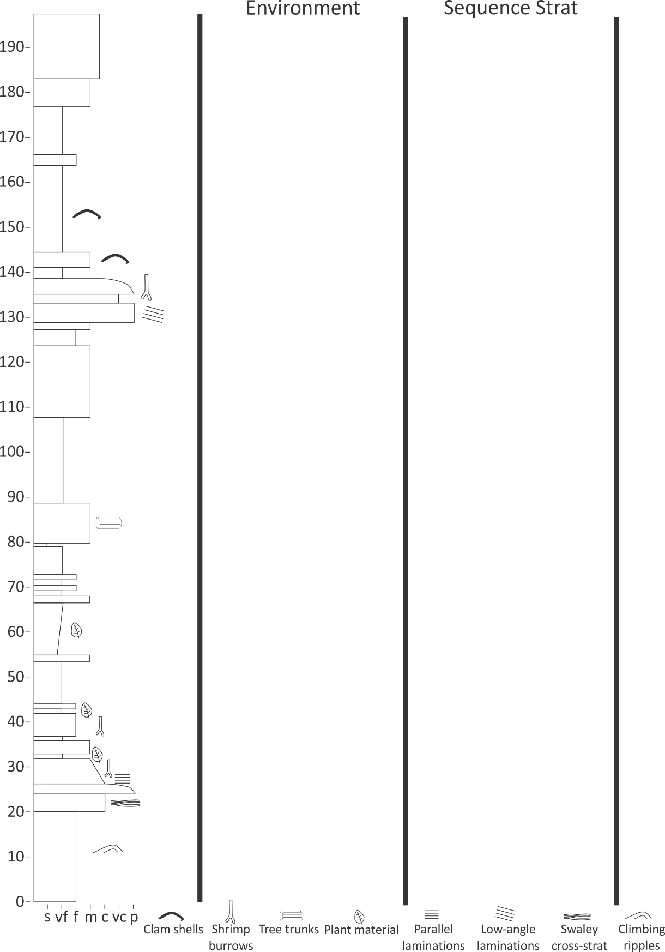
This section is incomplete, so you should 1) interpret the environments and sequence stratigraphy where the outcrop is present, 2) draw the most plausible succession of environments in the gap between the lower and upper outcrop section (labeling the environments and sequence stratigraphy that you used), and 3) draw the most plausible succession of environments above the upper outcrop section given the known pattern of systems tracts.

