EART120: Aeolian Sediments Name: _______________________

Aeolian facies are highly distinctive and easily recognized, in general. More specific details, such as reconstructing dune geometry or deciphering controls on accumulation and preservation, are much more complex. With this exercise, you will get experience looking at aeolian sedimentary deposits, using Gigapan images. All images are from the Jurassic Navajo Sandstone of Utah and Arizona.

Image 1 (http://gigapan.com/gigapans/32031)

Look at the dune deposits that make up the lower half of the smooth cliff face (above the roadside platy outcrop). Question 3 focuses on the area highlighted by the rectangle. Question 4 focuses on the surface noted by the black line.

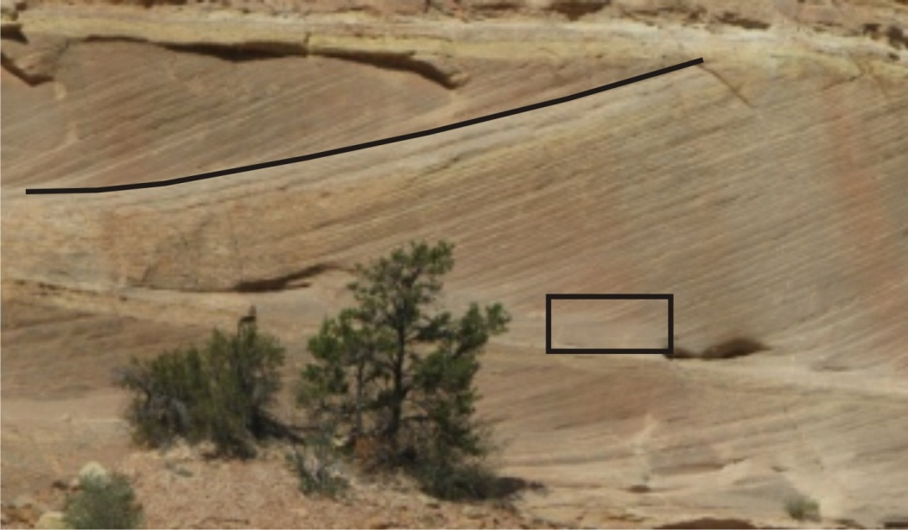

- What direction was dune migration? Use left, right, into the cliff, or out of the cliff.

- How does the size of these aeolian cross-beds differ from subaqueous (i.e. river) dunes? List one other shape difference between aeolian and subaqueous cross-stratification.

- I think the area in the highlighted rectangle contains both grainflow and grainfall strata. Make a detailed sketch of the beds in the rectangle, showing your best interpretation of the distribution of grainflow and grainfall.

- What do you think the surface (highlighted by the thick line in the photo) represents?

- Examine the yellowish layer above the cross-beds. This probably represents the interdune flat area. The Navajo sandstone was a wet aeolian system, so the water table was near or at ground surface in interdune areas, allowing preservation of interdune sediment that would otherwise be eroded by wind. Describe the contact between cross-bedded unit and the yellow interdune bed: it is gradational, sharp, or erosive?

Image 2 (http://gigapan.com/gigapans/32037)

Aeolian deposits can come from simple dunes (single dunes that migrate across the surface) or from compound dunes (also called draas), which have multiple smaller dunes superimposed as part of a larger dune structure. This photo probably shows deposits from a compound dune.

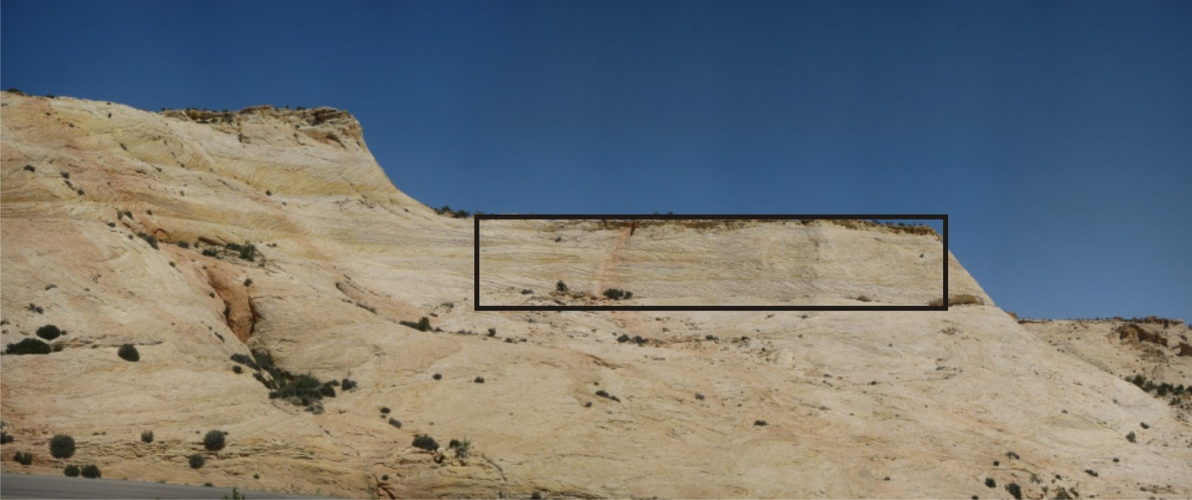

- Compare the uniformity of thickness and orientation of cross-beds in the selected rectangle to the beds in previous image. What characteristics of the original depositional environment might those differences reflect?

Image 3 (http://gigapan.com/gigapans/13167)

- Were the cross-beds in this section formed by simple or compound dunes? Explain why you made that conclusion.

Image 4 (http://gigapan.com/gigapans/13185)

- What do you think happened to form the sedimentary features observed at this outcrop?

