**EART120: Basin analysis Name: ______________________**

Basin analysis involves a suite of techniques for quantitatively measuring subsidence and sediment accumulation. It generally starts with the physics of heat flow, calculation of geothermal gradients, quantitative isostasy, flexure based on elastic theory, etc. It would take a whole course to cover the entirety of basin analysis, so this exercise will focus only on two very specific topics. You’ll investigate controls on fault-controlled subsidence in extensional basins, and patterns of flexural subsidence in foreland basins. For more detail (a lot more!), the book “Basin Analysis: Principles and Applications” by Philip Allen and John Allen is very thorough and extremely quantitative.

Part 1: Subsidence and extensional basins – the uniform stretching model

The first simplified yet realistic quantitative model for subsidence was McKenzie’s (1978) uniform stretching model. The equation is given on the next page. It’s kind of overwhelming, but is essentially an **isostatic balance between the average density of the vertical column of material before vs. after stretching, adjusted for differences in the average temperature of that column** (from the geothermal gradient). There are two competing factors: an increase in density after stretching promotes subsidence but an increase in temperature promotes uplift. The overall outcome is the balance between those two.



The lithosphere is uniformly and instantaneously extended by a stretching factor . The “uniform” term means that the crust and the subcrustal lithosphere are both extended by the same amount .



The model uses the following parameters:

yL is the initial lithosphere thickness. **It uses 125 km (125000 m)**.

yc is the initial crust thickness. **You will vary this** **(it should be in m).**

m* is the density of the mantle at 0° C**. It uses 3300 kg m-3**.

c* is the density of the crust at 0° C. **It uses 2800 kg m-3**.

v is the volumetric coefficient of thermal expansion. **It uses 3.28x10-5 °C-1**.

Tm is the asthenosphere temperature. **It uses 1333 °C**.

s is the density of the basin fill. **You will vary this**.

 is the stretching factor. **You will vary this**.



1. Calculate the average density of the column prior to extension for a crust with a density of 2800 kg m-3 and a mantle (subcrustal lithosphere and asthenosphere) with a density of 3300 kg m-3. Do this for two conditions, where the crust is 10% of the lithosphere and where the crust is 50% of the lithosphere.

Hint: the average density is weighted by the amount, so:

avg = c(yc/yL) + m(1 – yc/yL)

Which condition has higher initial density, thinner crust (10% of total) or thicker crust (50% of total)?



1. Calculate the average density of the equivalent column after to extension for a crust with a density of 2800 kg m-3 and a mantle (subcrustal lithosphere and asthenosphere) with a density of 3300 kg m-3. Do this for two conditions, where the crust was initially 10% of the lithosphere and where the crust was initially 50% of the lithosphere, but in both cases where the extension factor  was 1.5.

Hint: the average density is weighted by the amount, so:

avg = c(yc/yL * 1/ ) + m(1 – yc/ yL * 1/ )

For each condition (initial crust of 10% and 50%), how much has the density changed from the initial condition? Does that density change suggest that the column should subside or be uplifted? Which condition should have greater subsidence/uplift?

In reality, it is more complicated than this (even for this fairly simple model), because the geothermal gradient also changes, bringing hotter temperatures to shallower depths. Higher temperature leads to lower density, which would tend to favor uplift. So the isostatic balance needs to account for temperature, yielding this scary-looking equation:

$$y_{s}=-\frac{y_{L}\left[\left(ρ_{m}^{*}-ρ_{c}^{*}\right)\frac{y_{c}}{y_{L}}\left(1-α_{v}\frac{T_{m}}{2}\frac{y_{c}}{y_{L}}\right)-\frac{α_{v}T_{m}ρ_{m}^{*}}{2}\right]\left(1-1/β\right)}{ρ_{m}^{*}\left(1-α_{v}T_{m}\right)-ρ_{s}}$$

The output ys will be negative for subsidence and positive for uplift (and will be measured in meters). *This is the fault-controlled subsidence or uplift only*; longer-term thermal effects are neglected. If you want to know more about the derivation of this equation, see the Uniform Stretching handout at Canvas (note that I added a negative sign to the equation used here).

You can calculate fault-controlled subsidence (or uplift) from the uniform stretching equation using this website – <https://people.ucsc.edu/~mclapham/eart120/uniform_stretching.html>. Follow the directions in the following questions and plot your results on the graph on the next page, using the symbols provided in the legend. You can either enter the data into Excel or Google Sheets (or something else) to make a graph, or do it by hand using the template here:

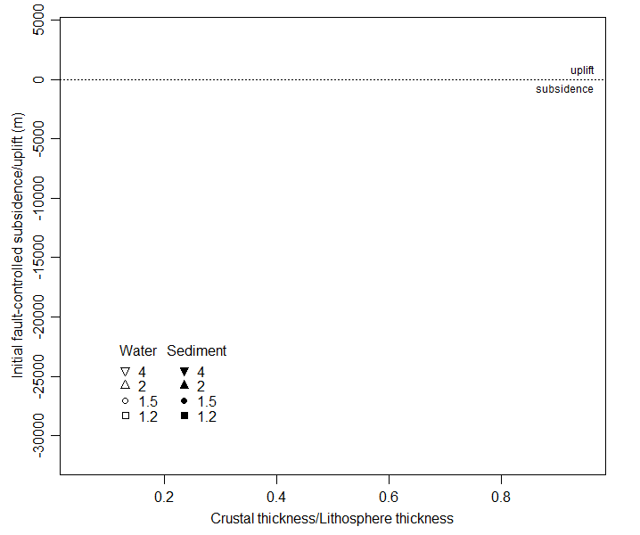

1. Set the stretching factor  to 1.5 (corresponding to a 50% extension of the lithosphere) and assume the basin is filled only with water (density s of 1000 kg m-3). Vary the crustal thickness by setting initial crust thickness (yc) to values of 20%, 40%, and 60% of the total lithosphere thickness yL (the total lithosphere thickness used here is 125 km, or 125000 m). Connect those three points with a straight line.

How does crustal thickness affect the amount of subsidence or uplift? Does extension of typical continental crust (~35 km thick, in a 125 km thick lithosphere) lead to subsidence or uplift?

1. What does your graph indicate about subsidence/uplift for a crust that is only 10% of lithosphere thickness? How does that compare to your calculation in question 2, based only on density change? What explains the difference between your calculation and the model?
2. Still assuming the basin is filled only with water, plot lines for subsidence/uplift as a function of crustal thickness, but now selecting stretching factors  of 1.2, 2, and 4 (note that the results will be linear, so you only need to choose two crustal thickness values per  value). How does the amount of extension affect the amount of subsidence/uplift?
3. Why does greater extension influence the results in that way?

To investigate, use the average density equation for a typical crustal thickness (35% of the lithosphere) and calculate column density prior to extension:

avg = c(yc/yL) + m(1 – yc/yL)

Then calculate column density with a stretching factor of 1.5 and of 4:

avg = c(yc/yL * 1/ ) + m(1 – yc/ yL * 1/ )

1. Finally, the line for subsidence as a function of crustal thickness when  = 1.5, but assume that the basin is filled with sediment (density s of 2000 kg m-3) rather than water. You can choose two crustal thickness values and connect them with a line.

How does this affect the amount of subsidence? Given your investigation of the isostatic density balance, why does this occur?

(Note: the uplift part of the graph is unrealistic here, because no sediment actually accumulates in uplifting regions).

Part 2: Flexure and foreland basins

The numeric calculations for flexure are complicated (involving fourth derivatives), so you’ll use a more qualitative approach with physical models.

Take one of each diameter of wooden dowel (one narrow and one wide; there are only five of each, so you’ll have to work in groups or take turns). First, use the narrow dowel to draw a horizontal chalk line on the board, representing the pre-loading continental crust.

1. Hold the right end of the dowel in place and gently press down on the left end (mimicking the loading of a fold-and-thrust mountain belt). Don’t bend it too far – you could break the dowel! Trace the deformed position and then describe the spatial distribution of subsidence or uplift as a function of distance from the mountain belt. Don’t erase the chalk yet!
2. Shift the dowel horizontally about one-quarter length to the right, hold the right side in place and gently press down on the left end. Try to exert about the same force you did the first time. Draw the new deformed crust position on the chalk board. Where is the subsidence rate (the difference between the two lines) the highest?
3. Fold-and-thrust belts typically build toward the foreland (the mountains, or deformational load, would gradually shift from right to left on the diagram above), so the flexure of the underlying plate also changes accordingly. Consider a point initially located far from the mountain front (on the far left side of the diagram above). How does the amount of accommodation space at that point change through time? Sketch the pattern graphically, with accommodation space on the horizontal axis and time (from oldest at the base to youngest at the top) on the vertical axis. Your line should trace the approximate change in the rate of subsidence (large amounts of subsidence on the far left) and uplift (right end of the horizontal axis) over time as the mountain belt migrates towards your position.

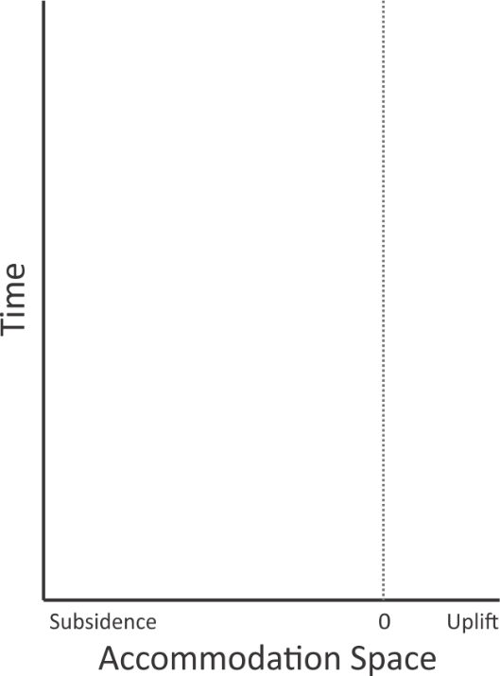

1. Next, use the wider dowel to draw a horizontal chalk line. Hold the right side in place a gently press down on the left end, using about the same force that you did previously. How does the flexural strength of the crust affect the amount of subsidence and the width of the basin (and therefore the position of the forebulge uplift)?