EART120: Alluvial fans Name: _______________________

Alluvial fans are important terrestrial depositional environments in the rock record, although they are not as widespread as fluvial systems. They are perhaps best known from mountainous and desert regions, but can form anywhere there are steep gradients (greater than a few degrees). Deposition on alluvial fans is dominated by debris flows and their hydrodynamics (laminar vs. turbulent), rheology, and sediment support mechanism influence the resulting facies characteristics. The main goal of this exercise is to determine characteristics that you can use to distinguish debris flow-dominated alluvial fan deposits from fluvial (particularly braided fluvial) deposits. You will also consider how accommodation space influences the geometry of alluvial fan deposits.

Part 1: Characteristics of debris flow deposits

Compare or contrast the predicted characteristics of debris flow deposits, based on what you know about their flow behavior, with the characteristics of braided fluvial conglomerates. Be precise when explaining the reasons for similarities or differences, based on specific aspects of hydrodynamics (laminar vs. turbulent), rheology, and/or sediment support mechanism.

- On average, how should the textural maturity of debris flow conglomerates differ from fluvial conglomerates? What processes cause those differences?

- Sedimentary cycles deposited in fluvial channels often exhibit normal grading, a gradual transition from coarser sediments at the bottom of the bed to finer sediments at the top. What would you expect in debris flows? What explains the similarity or difference?

- Basal contacts of beds can be described as gradational, sharp (meaning an abrupt but planar boundary), or erosive (referring to an irregular, scoured or channelized surface). What type of basal contact would you expect in a typical debris flow? What type of basal contact would you expect in a typical fluvial conglomerate bed? How does the flow hydrodynamics in each system control the nature of the basal contact?

- You have learned about and seen clast alignment in fluvial conglomerates. Preferred alignment of clasts is rare in debris flows, but it can occur. How will the long-axis orientation of clasts differ between debris flows and fluvial conglomerate? Why does that difference occur? (Think about the sediment transport mechanisms.) Where within the debris flow bed (base, middle, upper) would you predict clast alignment to be most likely? Why is it more likely to develop there?

- The diagram on the next page presents a labeled facies model for hyperconcentrated flow (“sheetflood”) deposits. Using your conclusions from questions 1 to 4, draw a similar facies model for a typical debris flow conglomerate. You can draw it next to the hyperconcentrated flow model. Use an approximate grain size profile and label important diagnostic features.

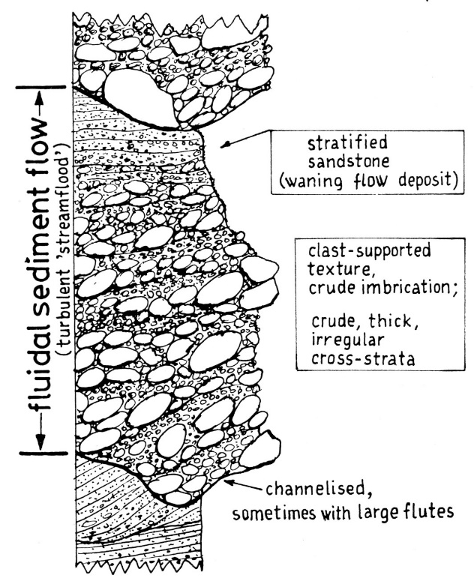

Part 2: Controls on alluvial fan geometry

You have heard the term aggradation before, in the context of a river deposit building upward. A river will aggrade when it deposits sediment such that the channel ends up at a higher elevation at a later time. There is a related term, progradation, that refers to a depositional environment building away from the source region (or in an ocean-ward direction, away from the coastline, for marine sediments). For example, an alluvial fan that grows outward, over the former valley floor, is prograding.

- Use Google Earth or Google maps to look at alluvial fans in Death Valley (latitude 36.1, longitude -116.8). How does the width of the fans differ between the west and east side of Death Valley? What does this tell you about the relative degree of aggradation vs. progradation on the two sides of the valley?

- The active fault in Death Valley is located on the east side of the valley. How does the rate of accommodation space creation influence progradation and aggradation of the fans?

- The climate in Death Valley was wetter in the Pleistocene. Assuming the rate of fault movement was, on average, similar to today, how would the balance between progradation and aggradation have changed?

