Name: _________________________

EART120: Provenance of Cretaceous sediments of the Great Valley Group

The Great Valley Group (or Sequence) was deposited in a Cretaceous forearc basin in front of the Sierra Nevada arc. Some of the key rocks in the source area are the Western and Northern Sierra terranes (primarily Paleozoic and Mesozoic metasedimentary rocks intruded by 140-170 Ma plutons) and the Sierra Nevada batholith itself (125-82 Ma granitic rocks). Much of the exposed strata records deposition in deep-marine submarine channels and fans on the continental slope, similar to the modern Monterey submarine canyon.

You will use detrital material contained in Great Valley strata to reconstruct the geomorphic evolution of the source area and discuss sediment transport pathways from the arc to basin.

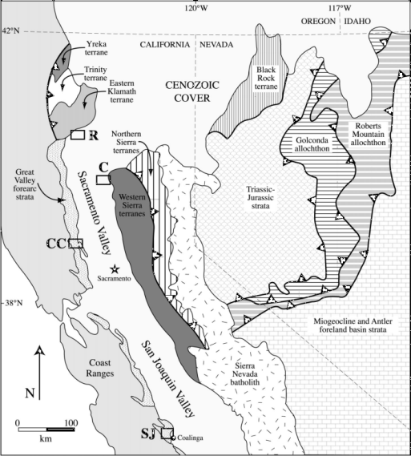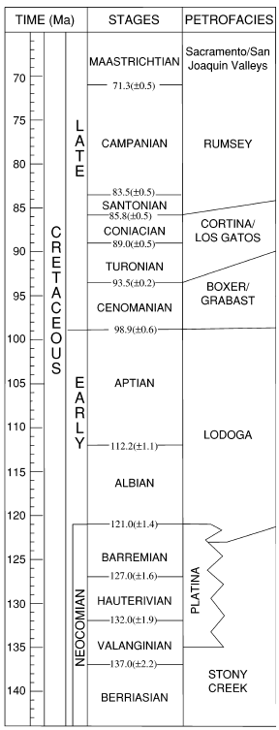
Fig. 1. (left) Location map showing outcrop area of Great Valley forearc strata relative to source areas in the Western and Northern Sierra terranes and Sierra Nevada batholith. Location boxes C (Chico), CC (Cache Creek), and SJ (San Joaquin) refer to locations of detrital zircon sampling in part 3. (right) Stratigraphic framework of Cretaceous Great Valley strata, which have been divided into several “petrofacies” based on sandstone composition.

Part 1. Compositional tracers of provenance

Petrographic studies of provenance have been used extensively in provenance studies and continue to be a standard method despite the proliferation of modern geochemical and isotopic techniques.

Plot the quartz (Q), feldspar (F),and lithic (L) percentages for each petrofacies (listed in the table below) on the QFL diagram. Make sure to label the points!

Table 1. Quartz, feldspar, and lithic percentage counts from four petrofacies (see fig 1 for their ages).
Petrofacies | Q | F | L
Rumsey | 42 | 33 | 25
Cortina | 36 | 31 | 33
Boxer | 22 | 26 | 52
Stony Creek | 19 | 24 | 57

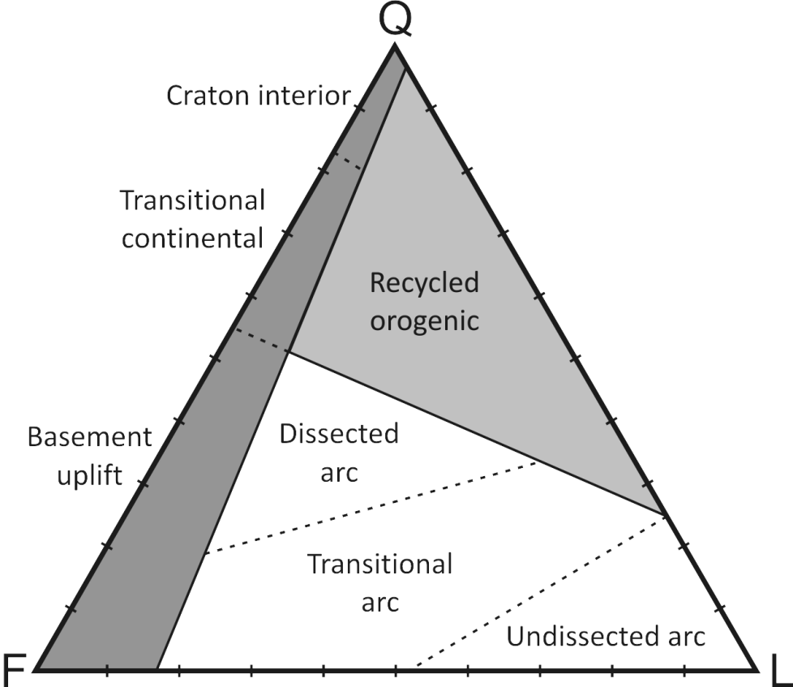

- How does the provenance change over time? What does that tell you about the geomorphic evolution of the Sierra Nevada arc?

Part 2: Geochemical tracers of provenance

Isotopic systems such as Sm/Nd or ⁸⁷Sr/⁸⁶Sr can also trace provenance if the isotopic compositions of rocks in the source region are known.

Sm/Nd (measured with the epsilon notation ε_{Nd}) measures the evolution of the mantle reservoir so is a record of the age at which the rock was extracted from the mantle. The elements behave similarly during weathering and diagenesis so sediment weathered entirely from Devonian granites would have the same ε_{Nd} as the granites themselves. More negative ε_{Nd} values correspond to older mantle extraction ages.

Strontium isotopes (⁸⁷Sr/⁸⁶Sr, also reported here with the epsilon notation) are a measure of magma differentiation. Differentiated continental rocks have high values, whereas primitive mantle rocks (like mid-ocean basalts) have low values. In an arc, higher values occur in continental arcs, indicating more crustal contamination.
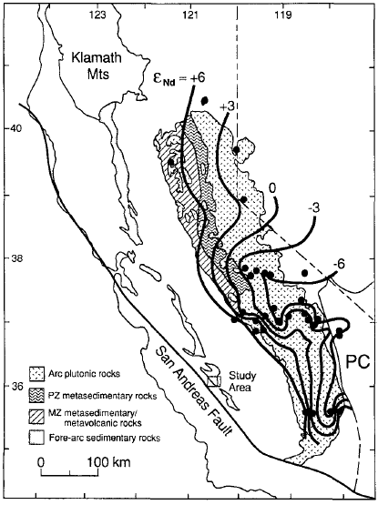
Fig. 2. Epsilon neodymium (ε_{Nd}) contours showing the generally eastward decline in ε_{Nd} values from west to east across the Sierra Nevada arc (reflecting increasing contribution from cratonic basement).

Table 2. Neodymium and strontium isotope systematics of Great Valley Group samples.
Age (Ma) | ε_{Nd} | ε_{Sr}
73 | -3.2 | 22.1
77 | -4.3 | 32.7
80 | -4.0 | 37.0
81 | -4.3 | 40.5
84 | -1.8 | 22.6
88 | -3.8 | 31.4
90 | -1.4 | 13.1
92 | -2.3 | 22.9
94 | -0.7 | 10.7
97 | -1.6 | 20.7

Plot the ε_{Nd} from table 2 on the left panel of figure 3 below. Also, compare the ε_{Nd} and ε_{Sr} values to the ranges expected from probable sources areas.

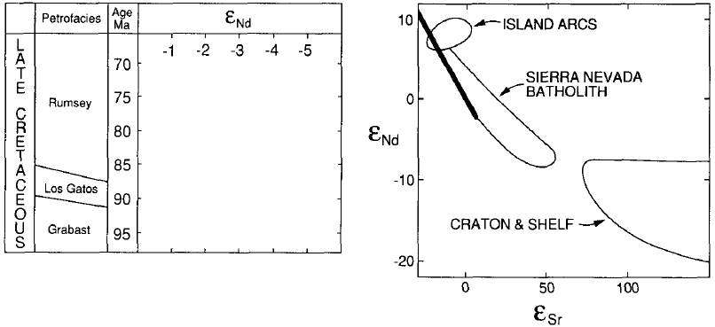
Fig. 3. (left) Temporal variations in ε_{Nd} in the Great Valley succession. (right) Nd and Sr isotope systematics of rocks in the source region.
- What do the neodymium and strontium isotope values tell you about the source area over time?

Part 3: detrital zircon age tracers of provenance

Single-crystal analyses, such as U-Pb age dating of detrital zircons, are a sensitive tracer of provenance. In contrast to whole-rock methods like Nd or Sr isotopes, which integrate and mix grains potentially from multiple sources, single-crystal U-Pb dates give the precise age for that specific grain. Because of that, they give a detailed fingerprint of the age of the source area.

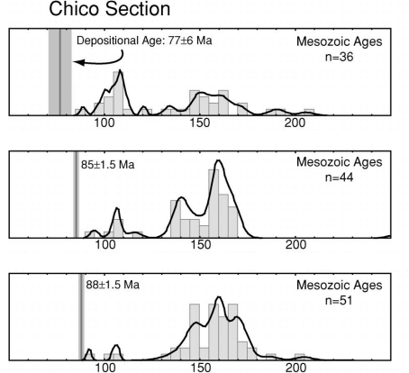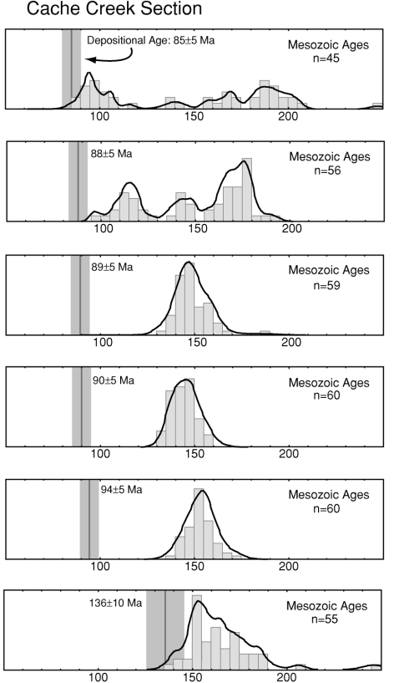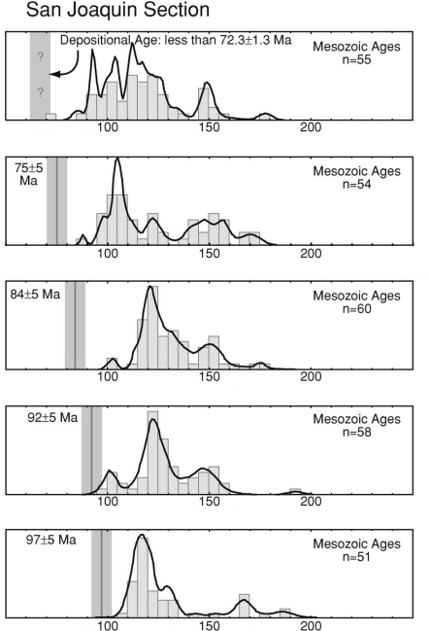
Fig. 4. Detrital zircon age spectra for samples from the Chico (box C on fig. 1), Cache Creek (box CC) and San Joaquin (box SJ) sections. The histogram bars show the abundance of crystals of a given age, between 80 and 200 Ma. The gray line and shaded box indicate the depositional age of each sample.

- Examine the detrital zircon age spectra in figure 4. How does the relative contribution of different source areas (especially the 140-170 Ma plutons in the Western Sierra terrane and the 125-86 ma plutons in the Sierra Nevada batholith) change over time and geographically (in the three different areas)?

