EART120: Reefs and miscellanea

This exercise covers a few odds-and-ends left over in carbonate sediments, focusing mostly on reefs. You’ll also get to look at some reef and microbialite samples. This exercise doesn’t need to be turned in; it’s just for your reference.

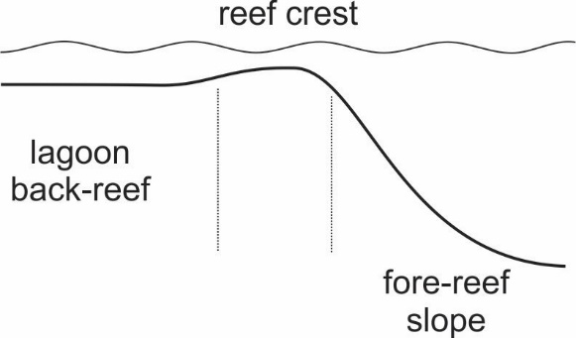

- What types of carbonate rocks (using the Dunham classification) would you predict in the lagoon (or back-reef), reef crest, and fore-reef (or slope)? What are the main types of allochems in each area?

- How would the importance of destructive processes (wave energy and bioerosion) vary across a transect from lagoon to fore-reef?

- What is the main difference between a true reef and a mound? How are they similar?

- Look at one of the reef rocks (all are from Lower Cambrian reefs) and identify framework constructors, microbial binders, and cavities (filled with sediment and/or cement).

- Look at one of the samples of wrinkle structures (one is Lower Cambrian, the other is Lower Triassic). These are microbially-induced sedimentary structures, formed by trapping and binding of sediment grains by microbial mats in siliciclastic rocks (note the prominent mica grains in the Lower Triassic example). How do these wrinkle structures differ from current ripples or wave ripples?

