EART120: Carbonate platforms Name: ______________________

Carbonate platforms have unique spatial distribution and vertical cyclicity of facies, due to their geometry (flat top with steep sides). In this exercise, you will consider how platform geometry and the intrinsic behavior of the carbonate factory influence facies distribution and platform growth.

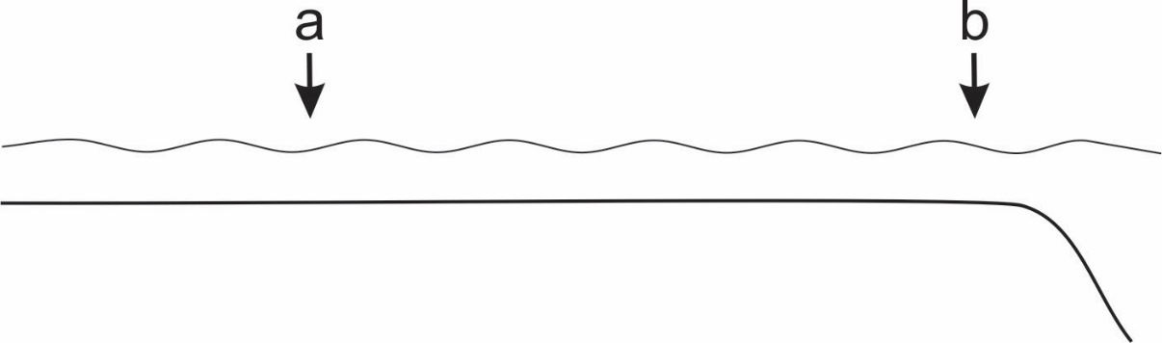

- Contrast the water energy at “site a” when sea level is low (a lowstand, platform only shallowly flooded) versus when sea level is high (highstand, platform is flooded more deeply). What causes this variation in water energy?

- Draw idealized, schematic vertical profiles of the facies cyclicity at points “a” and “b” (assuming allocyclic processes). Label the position of key sedimentary structures or types of allochems in the cycle.

- Carbonate cycles, especially on platforms, are dominantly shallowing-upwards cycles; the deepening-upward portions are thin or absent. This has commonly been attributed to a “lag time” where carbonate sedimentation does not restart (or is very slow) until water depths on the platform reach some threshold. Speculate on some physical or biological mechanisms (remember: carbonates are largely biogenic) that could contribute to the lag.

- The nature of slope sediments differs on the windward and leeward side of the platform, at least for open-ocean unattached platforms. The windward side means that the wind, and therefore the prevailing current, is directed from the open ocean onto the platform; the leeward side is the reverse. How would the rate of carbonate sediment supplied to the slope differ between windward and leeward margins? Why?

- How will the amount of carbonate sediment shed from platform to slope differ between highstands (when the platform will be flooded) and lowstands (when the platform will be emerged or only shallowly covered)? Why (hint: there are two main factors)?

- In which direction (windward or leeward) should the platform margin prograde most rapidly? Why?

- When should the platform margin prograde most rapidly – during lowstands or highstands? Why? How and why does this differ from siliciclastic shelf sediments?

