EART120: Carbonate processes Name: _________________

Carbonate sediments, like siliciclastics, are influenced by water energy. However, carbonates also have unique properties – most notably, they grow in place rather than being weathered and transported. In this exercise, you will consider how the processes of carbonate sedimentation influence the distribution of allochem and rock types.

- Given the generalized depth and energy profile of a carbonate ramp (you’ll learn more about carbonate ramps next class), indicate the predicted depth distribution of a) ooids, b) skeletal grains, c) intraclasts, d) grainstone sediment, e) wackestone, and f) micritized grain envelopes. Use horizontal lines of varying thickness (thicker line = more abundant) to show the depth distribution. Separately explain how energy and carbonate processes control the distribution.

Figure 1. Generalized carbonate ramp profile (FWWB=fair-weather wave base, SWB=storm wave base).
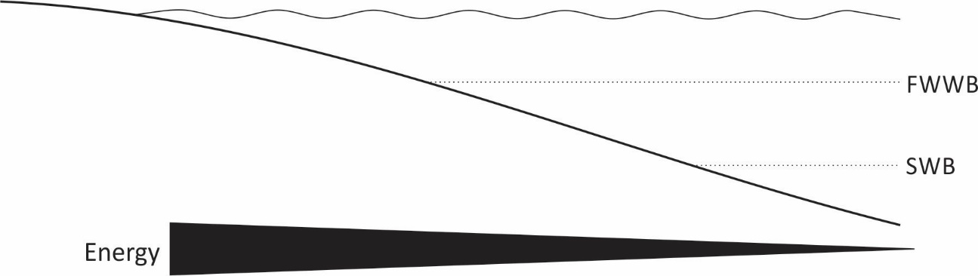

- Given the generalized depth and energy profile of a carbonate platform (you’ll learn more about carbonate platforms next week), indicate the predicted distribution of a) ooids, b) aggregates, c) peloids, d) grainstone sediment, and e) wackestone. Use horizontal lines of varying thickness (thicker line = more abundant) to show the distribution. Separately explain how energy and carbonate processes control the distribution.

Figure 2. Generalized carbonate platform profile (windward side to the right).

- The Phanerozoic can be divided into times of “aragonite seas” (when aragonite was the favored precipitate) and “calcite seas” (when calcite was favored). Use the data below to identify times of aragonite and calcite seas. You don’t know the precise threshold (and it varies with temperature), so just label three intervals that were most likely aragonite seas and three that were most likely calcite seas. Why is the Mg/Ca ratio important?
