EART120: Barrier Islands Name: _______________________

- Interpret the depositional environments, divide the section into systems tracts, and label the sequence stratigraphic surfaces. All coastal and fluvial environments are fair game!

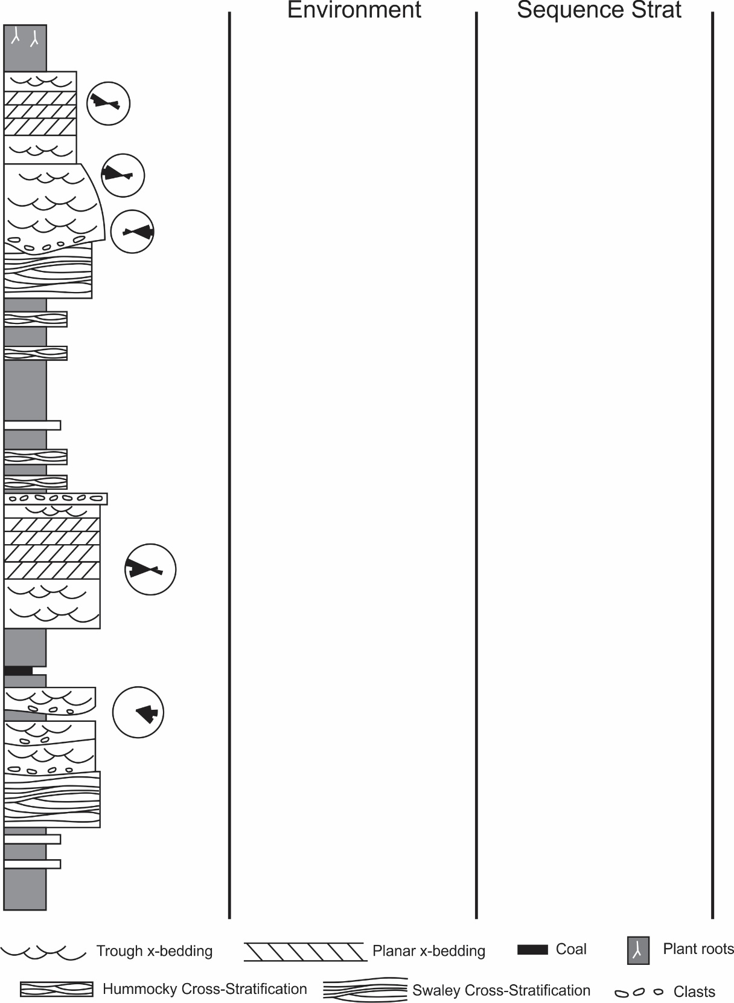

- Dakota Sandstone (Cretaceous, Utah): http://gigapan.com/gigapans/81516
Also see http://gigapan.com/gigapans/81493 for a better and more extensive view of the basal unit.

Interpret the depositional environments in this section (including the basal unit that is barely visible in this photo). Mark any important surfaces and interpret the sequence stratigraphy. As with many real sections, sedimentary structures and other clues are sparse, so you will need to make a consistent story using limited information.

