EART120: Delta environments Name: _________________

Gigapan 1: Thompson Canyon (Cretaceous, Utah), http://gigapan.com/gigapans/81597

- This section contains deltaic deposits. Draw lines separating delta environments and label the environments (prodelta, delta front, delta plain interdistributary bay, delta plain distributary mouth bar, etc.). Was this succession deposited during normal regression or forced regression? How do you know?

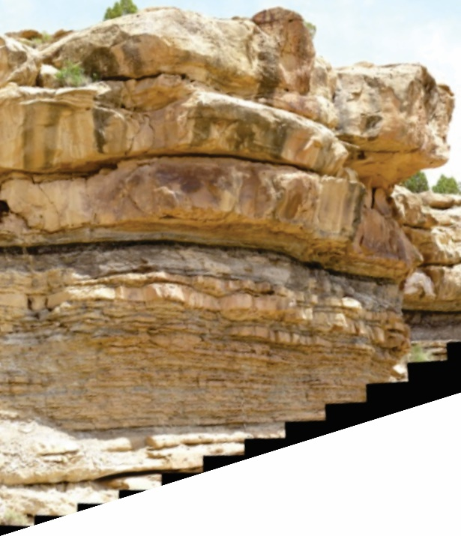

Gigapan 2: Chimney Rock sandstone (Cretaceous, Wyoming), http://gigapan.com/gigapans/8285

- Draw a stratigraphic section of the profile indicated by the vertical line, indicating depositional environments, systems tracts, and sequence stratigraphic surfaces. Identify the contacts between environments as gradational, sharp, or erosive. Facies found at points A-D are described on the next page.

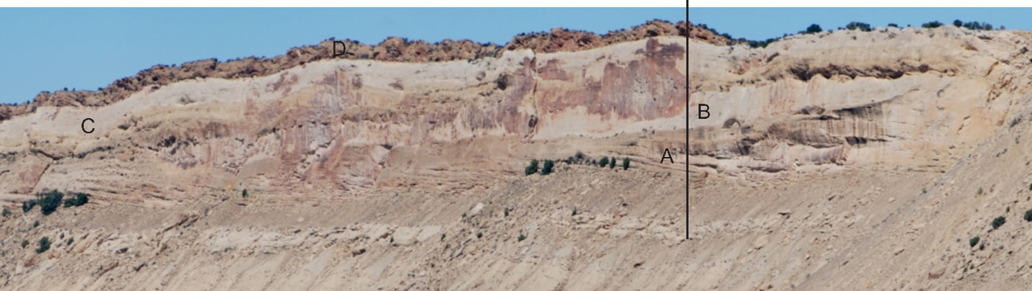

- What direction was the shoreline (to the left or to the right)? How do you know?
Facies A: Hummocky-cross-stratified (HCS), parallel-laminated, and wave- and current-ripple laminated very fine- and fine-grained sandstones. The sandstone beds are 10-30 cm thick and are interbedded with intensely bioturbated mudstone, siltstone, or sandstone beds, 20–40 cm thick. The mudstone intervals decrease and sandstone intervals increase in thickness upwards and updip.
Facies B: Fine- to medium-grained sandstone, dominated by parallel-laminated sandstones with trough cross-stratified, current ripple-laminated, or climbing ripple-laminated intervals. It commonly displays internal erosion surfaces that cut down a few decimeters. In places wave-rippled and swaley-cross-stratified sandstone intervals occur.
Facies C: Amalgamated beds, 2–5 m thick, of parallel- and wave-ripple-laminated, trough- and swaley cross-stratified, fine- to medium-grained sandstones. Parallel-laminated beds with wave-ripple-laminated interbeds dominate the facies. In some places the plane-parallel beds are interbedded with trough-cross-stratified sandstones. Swaley-cross-stratified beds occur locally.
Facies D: Unidirectional, fine- to coarse-grained trough cross-stratified lenticular sandstones. Other lenticular sandstone bodies consist of compound-cross-stratified and locally bidirectional cross-stratified fine- to medium-grained sandstones with reactivation surfaces and occasional mudstone drapes. Locally coaly mudstones and coals occur at the tops of the lenticular sandstones. The basal erosion surfaces are lined by clay-clast conglomerates or wood fragments.

- Draw lines separating depositional environments and label the environments as specifically as you can. Also draw lines (sequence stratigraphic surfaces) that separate the systems tracts, label the systems tracts, and label the sequence stratigraphic surfaces.

