EART120: Shoreline shifts and systems tracts Name: _________________

Sequence stratigraphy was designed to interpret stacking patterns of facies in coastal environments, subdividing the base level cycle into systems tracts on the basis of shoreline shifts. We will use terms like transgression or progradation often in upcoming classes, and everything will be discussed in terms of the systems tracts, so it is important to be very familiar with the terminology. In this exercise you will identify prograding and retrograding facies and determe systems tracts. All columns use the following five environments: fluvial, beach, shoreface, offshore-transition, and offshore (see Fig. 1).

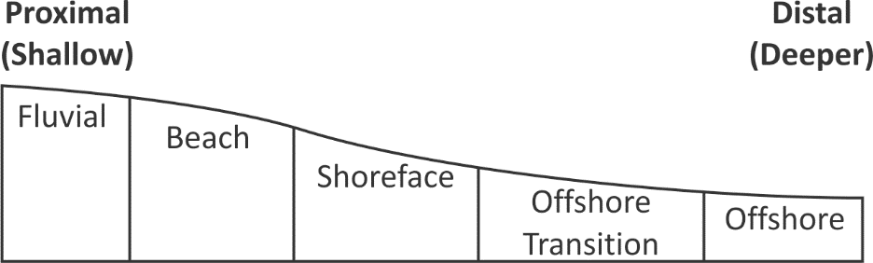
Fig. 1. Onshore-offshore transect showing lateral relationships among the five depositional environments.

Part 1: Transgression and Regression

- Identify whether the facies stacking in the columns below represents progradation (and therefore regression) or retrogradation (and therefore transgression).

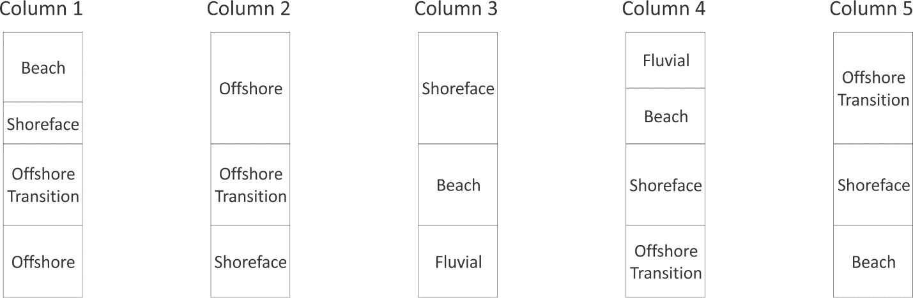

Part 2: Systems Tracts

- The columns below use the same five environments as shown in figure 1. On each column, draw arrows indicating progradational or retrogradational facies trends, corresponding shoreline regression or transgression, and label the relevant systems tracts. You should add the maximum flooding surface and the maximum regressive surface (if present). An example column has been completed below.

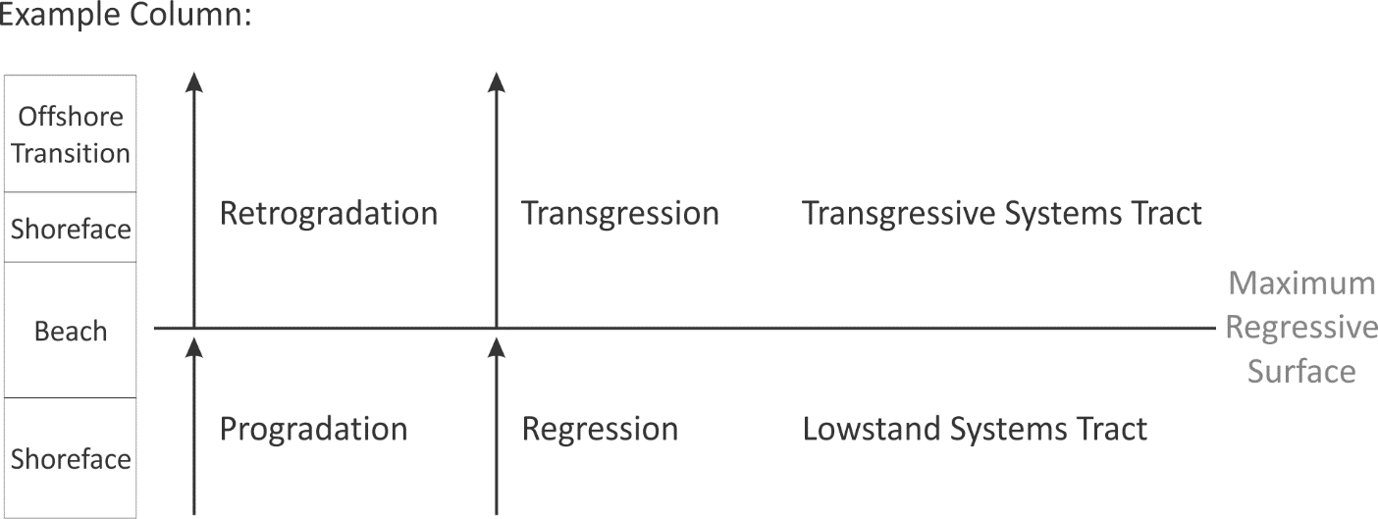

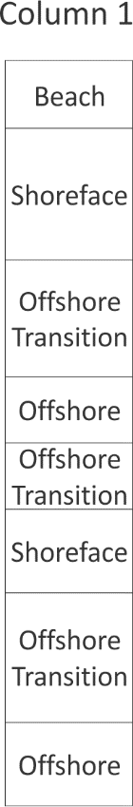

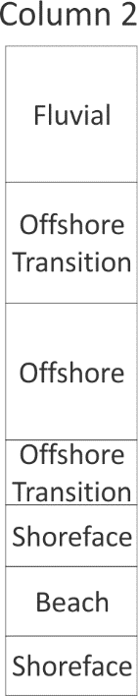

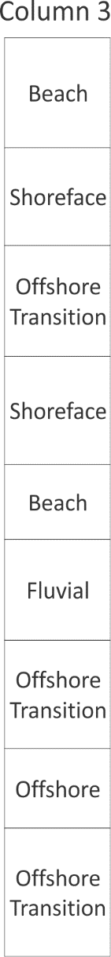
- The map below shows the position of two stratigraphic columns: one from the beach setting and one underneath the delta (assume that the “delta” environment is equivalent in onshore-offshore position to “beach” on figure 1). The columns are aligned so that the vertical scale represents time (the vertical time scale is the same in both columns). Label times of progradation and retrogradation, transgression and regression, and systems tracts as you did for the previous columns. How and why does the facies stacking pattern differ between beach and delta?

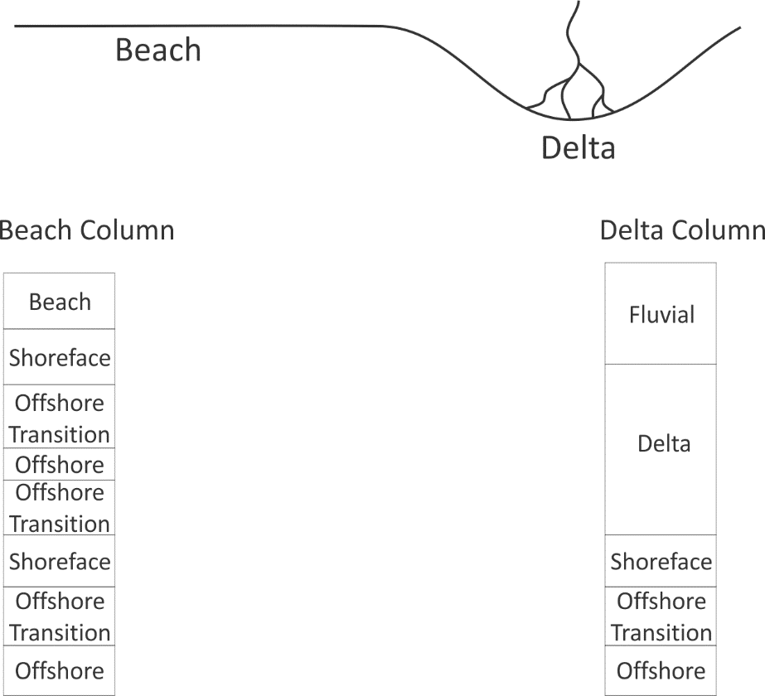

- Consider an onshore-offshore transect where base level change is entirely caused by fluctuating sea level (i.e., tectonic subsidence is the same everywhere across the basin). Will the maximum regressive surface or maximum flooding surface be synchronous (occurring at the same time everywhere) or diachronous (occurring at different times across the transect)? Why?

