EART120: Deep-sea sediments Name: ______________________

Sediments that accumulate far from continental margins are dominated by pelagic deposition, the gradual settling of particles from the surface ocean to the seafloor. Those particles can be windblown or even extraterrestrial dust, but are most often microscopic shells of calcareous or siliceous organisms. This exercise focuses on calcareous sediments; you will consider the factors that influence the distribution of carbonate accumulation.

- Compare the distribution of carbonate sediments in Figure 1 to the seafloor bathymetry in Figure 2 (see eCommons for a colors version, if necessary). How does the depth of the CCD differ (in a relative sense) between the North Pacific and North Atlantic oceans?

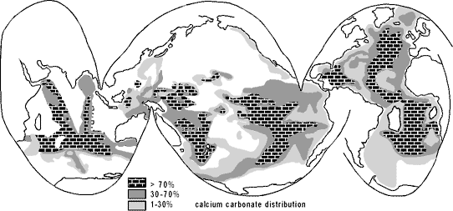
Figure 1. Geographic distribution of carbonate sediment in deep-sea sediments.

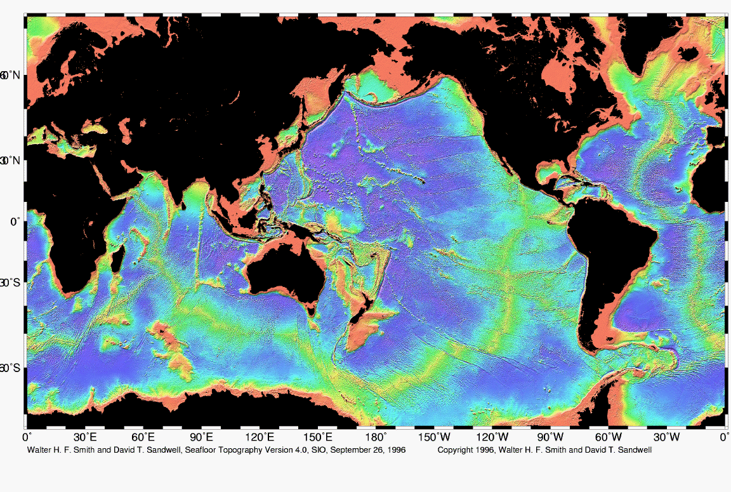
Figure 2. Color-coded ocean bathymetry (warm colors are shallow water, cool colors are deep water)
- All photosynthesis (the fixation of CO₂ to organic matter) in the ocean occurs in the uppermost 200 m. After those organisms die, they sink towards the ocean floor and the organic matter is remineralized (converted back to CO₂ by bacterial and animal respiration). How will pH differ between surface and deep ocean? Given that, how will carbonate ion concentration differ between surface and deep?

- Given ocean thermohaline circulation (Figure 3), what causes the difference in CCD depth between the North Pacific and North Atlantic oceans?

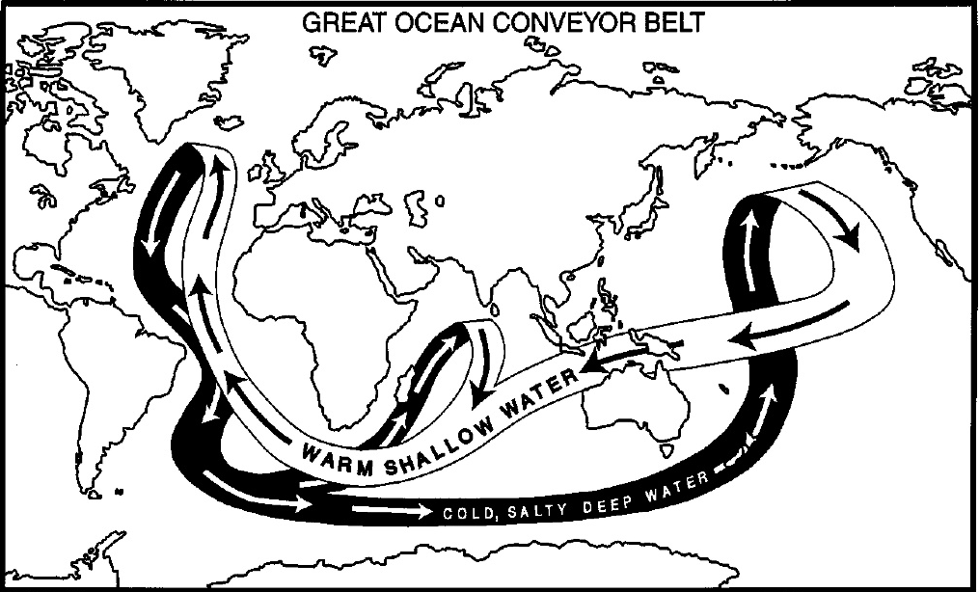
Figure 3. Thermohaline circulation, showing deep-water formation in the Atlantic.

- Ocean thermohaline circulation may be slower in greenhouse climates. Assuming the rate of organic matter export from surface to deep ocean remains constant, how would the Pacific-Atlantic difference in CCD depth be changed?

- How would an increase in export of organic matter from the surface to deep ocean affect the depth of the CCD? How would it affect the Pacific-Atlantic difference in CCD depth?

- How would the depth of the CCD respond to an increase in continental weathering?

