EART120: Submarine fan cyclicity Name: ______________________

Depositional cycles, the repeated vertical stacking of predictable facies associations, are common features of sedimentary deposits. Cyclicity is especially common in environments characterized by intrinsic lateral migration (like submarine fans or meandering rivers). The vertical relationships between facies can also help you narrow down the specific environment represented by a given facies. Even if the sedimentary structures of that facies are not diagnostic in isolation, their position above or below other facies will provide additional constraints.

This exercises focuses on cyclicity in submarine fans, considering both autocyclic and allocyclic causes of cyclicity. Remember, you should always first attempt to interpret cyclicity as autocyclic in environments with inherent natural migration, like submarine fans or fluvial channels. Only invoke allocyclic causes after you have identified (or ruled out) autocyclic processes.

Part 1: Autocyclic facies stacking

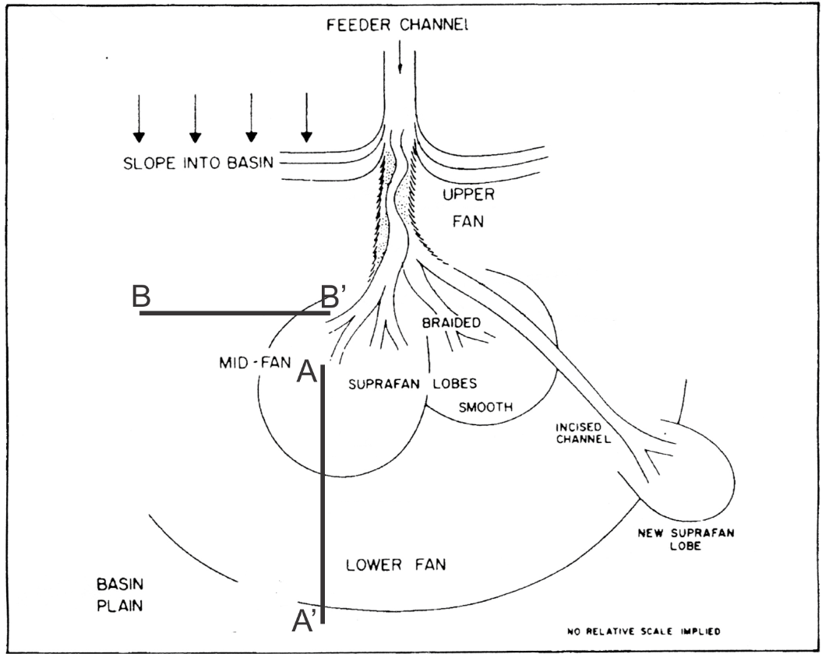
Figure 1. Point-source submarine fan, showing division into upper, mid-, and lower fan environments.

- Using what you have learned about the distribution of grain size, bed thickness, and sedimentary structures, draw a schematic facies model showing the expected vertical succession of facies at location A’ if the mid-fan prograded along the A-A’ line. (Progradation could also be allocyclic if it is caused by base level changes.)

- Draw a schematic facies model at site B, showing the expected vertical succession of facies if the suprafan lobe and channel migrated from its current position along the B-B’ line to site B.

- Now consider the opposite case, where the suprafan lobe and channel migrated laterally from site B to its current position. Draw a schematic facies model showing the vertical succession of facies expected at location B.

Part 2: Allocyclic facies stacking

Sequence stratigraphy is very difficult to apply in submarine fan systems, in part because of the immense scale of these depositional sequences, so we won’t really try. Instead, you will think just about the effects base level changes may have on the depositional character (grain size, nature of deposits) of submarine fans.

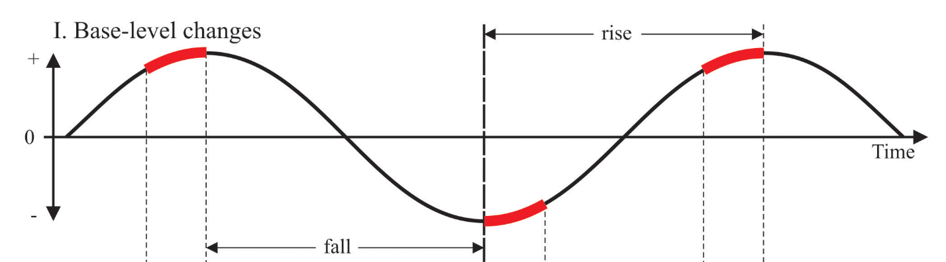

Figure 2. Idealized base level cycle.

- Construct a graph showing base level cycles (like in Figure 2) and the predicted (a) amount of sediment supplied to the submarine fan, (b) grain size of sediment supplied to the fan, and (c) prevalence of slumps in the slope/upper fan environment. Explain why each trend occurs, thinking about accommodation space and sediment transport.

- When during the base level cycle are fans most likely to prograde? When should progradation rate reach its maximum?

