EART120: Submarine fans and turbidites Name: ______________________

Submarine fans are the largest depositional systems on Earth and can be thousands of kilometers long and hundreds of kilometers wide. As deep marine environments, they are also the ultimate site of sediment accumulation, after it has been transported through fluvial and coastal areas.

The best-known submarine fans are small, sand-rich, point-source systems like the example illustrated below. Fans can also have multiple sources or a continuous source, or can be gravel- or mud-rich, resulting in a different pattern of facies. Fan deposition is dominated by submarine sediment-gravity flows, including turbidity currents. The purpose of this exercise is to use what you have learned about turbidity current behavior to reconstruct the expected facies at different points on the submarine fan.

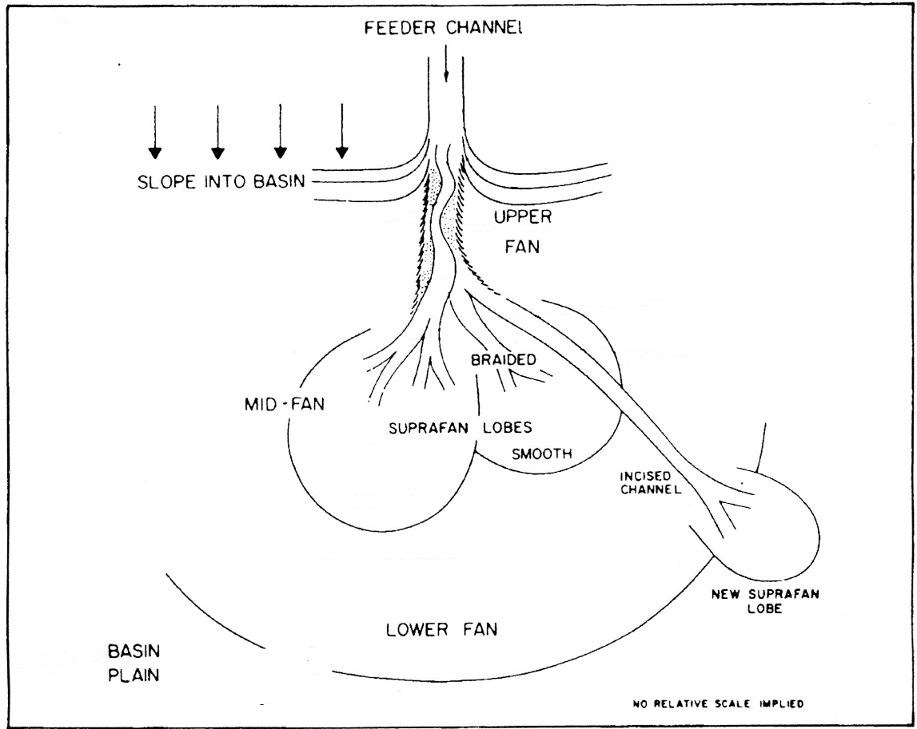
Figure 1. Point-source submarine fan, showing division into upper, mid-, and lower fan environments.

- The lower fan is the distal part (furthest from the sediment source) of the fan, typically located on the low-gradient basin plain. What type of sediment-gravity flow (debris flow, grain flow, turbidity current, fluidized flow) would you predict to dominate in this setting? Why (think about flow rheology)?

- Sediment is supplied to the fan through a single point-source feeder channel (in this type of fan). Considering the unchannelized part of the lower fan, how should bed thickness change from proximal (closer to the source) to distal parts? How should grain size change along that proximal to distal transect? What physical processes affect bed thickness and grain size in these deposits?
In the mid-fan, sediment-gravity flows are often confined to submarine channels, which may be quite sinuous and typically are bounded by a raised levee, similar to fluvial channels. Sediment-gravity flows may actually be thicker than the depth from channel base to levee top, favoring a process called flow stripping. Flow stripping can occur at channel bends, where the lower part of the flow follows the channel bend while the upper part continues in a straight line due to its momentum. This results in the top of the flow being stripped away from the base.

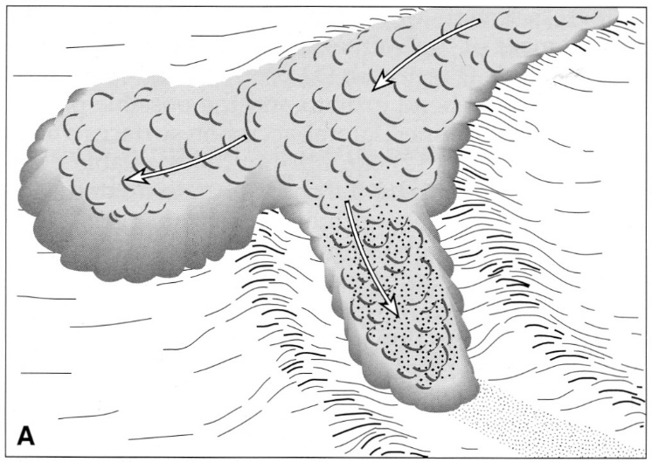
Figure 2. Cartoon illustrating the process of flow stripping at a channel bend.

- Assuming the flows are turbidity currents, what will likely happen to the upper part of the flow after it is stripped? Explain why.

- How will the grain size differ between deposits on the levee and mid-fan (sourced from the stripped flow) and deposits in the channel? Why?

- How should bed thickness and grain size change along a lateral transect from levee to fan lobe, within the mid-fan environment?

- Where on the mid- or lower fan would you expect convolute bedding to be most common? Why?

- Where on the mid- or lower fan would you expect climbing ripples to be most common? Why?

The upper fan has the steepest gradient, is the closest to the sediment source, and is primarily represented by the submarine channel.

- What types of sediment-gravity flow (debris flow, grain flow, turbidity current, fluidized flow) would you predict to dominate in this upper-fan channel setting? Why (think about flow rheology)?

