Instructions for Collecting Trilobite Landmark Data

You will be using the program tpsDig to collect the landmark data. It should already be open but, if not, click the start button, go to “all programs” then the “tps” folder and click on tpsDig2.

1. First, familiarize yourself with the landmarks you will be collecting.

Always measure the left side of the cephalon (as shown in fig. 1 below)

Anterior
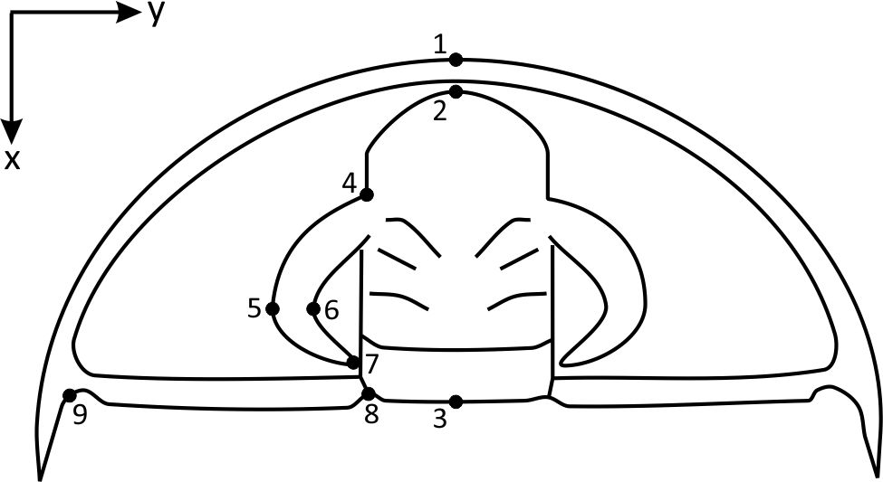
Posterior

Figure 1. Example cephalon of an olenellid trilobite with landmarks indicated

Place the landmarks as precisely as you can. Their exact position is described below (also see fig. 1).
- Furthest anterior (forward) point on the cephalon along the midline
- Furthest anterior point on the glabella along the midline
- Furthest posterior (backward) point on the cephalon along the midline
- Anterior side where eye meets side of glabella
- Lateral (left-most) point of eye
- Medial edge of eye, aligned with landmark 5
- Posterior tip of eye (or anterior side where eye meets side of glabella, if merged)
- Furthest posterior point on glabella at its left edge
- Genal angle (small notch on central posterior side of genal spine). NOTE, in very small specimens the most obvious spine is NOT the genal spine (it’s called the intergenal spine). The actual genal spine is much smaller and is a small knob or spine located to the anterior of the intergenal spine. If you have been assigned specimens B1, B2, O1, or U85A you will need to pay careful attention to this. Ask if you are unsure!

2. In the tpsDig program, click on the “File” menu, then “Input source” and “File.” This will open the file selection dialog box.

3. The “Trilobites” directory should already be selected, but you will need to change the file type. Use the “files of type” dropdown box (near the bottom) to change to “All graphics.” That should bring up the list of files in the large box above.

4. Double-click on the first image that you have been assigned to do. This should load the picture in the main program window.

5. The picture may be zoomed in too closely. If that’s the case, use the negative sign (“-“) box in the row of boxes near the top to zoom out until you can see the whole cephalon.

6. If you zoomed out, you will need to re-select the landmark tool – the blue cross-hair target box in the row of boxes near the top.

7. For each landmark, click the target on the proper place in the image. It is extremely important to click on the nine landmarks IN THE CORRECT ORDER. Also remember to select landmarks only on the left side of the cephalon. Be as precise as you can about putting the landmark in the correct spot. You will get a red dot and number for each landmark.

8. When you have selected all nine landmarks in the correct order, go to the “File” menu and select “Save data.” Use the same file name as the image you are working with (e.g., B1 or 11-1A-1).

9. Repeat steps 2-8 for your second assigned specimen.

