EART 101. Biogeography: Vicariance and Dispersal Name: _____________________

1. Figure 1 shows the similarity (measured as the percent of species common to both sites) of bivalve faunas on the western and eastern side of the North Atlantic, relative to distance (and time) as the ocean basin rifted. The data points record the similarity of all bivalves. Draw lines and label them to indicate approximately how the similarity trends for bivalves with planktotrophic and lecithotrophic larvae would differ from the average trend for all bivalves. Explain why the trends differ from the average.

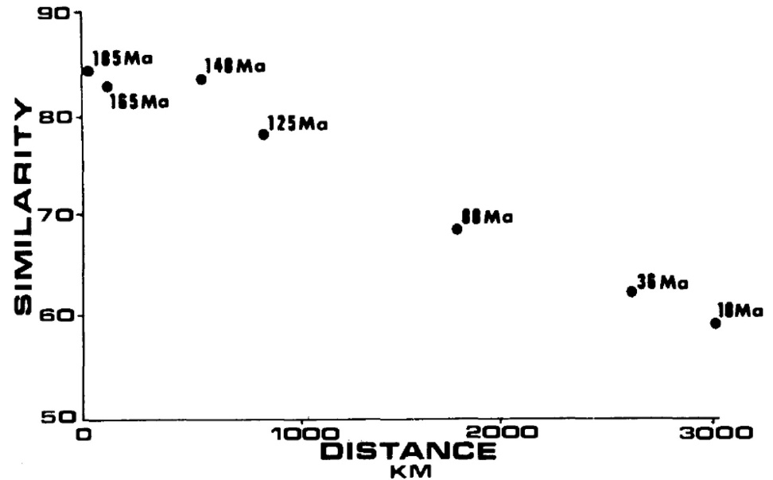
Fig. 1. Percent similarity between bivalve faunas on the western and eastern side of the North Atlantic relative to the width of the ocean basin. Data points represent different time intervals (ages are labelled) as the ocean basin rifted.

Use data in figure 2 to answer questions 2 and 3.

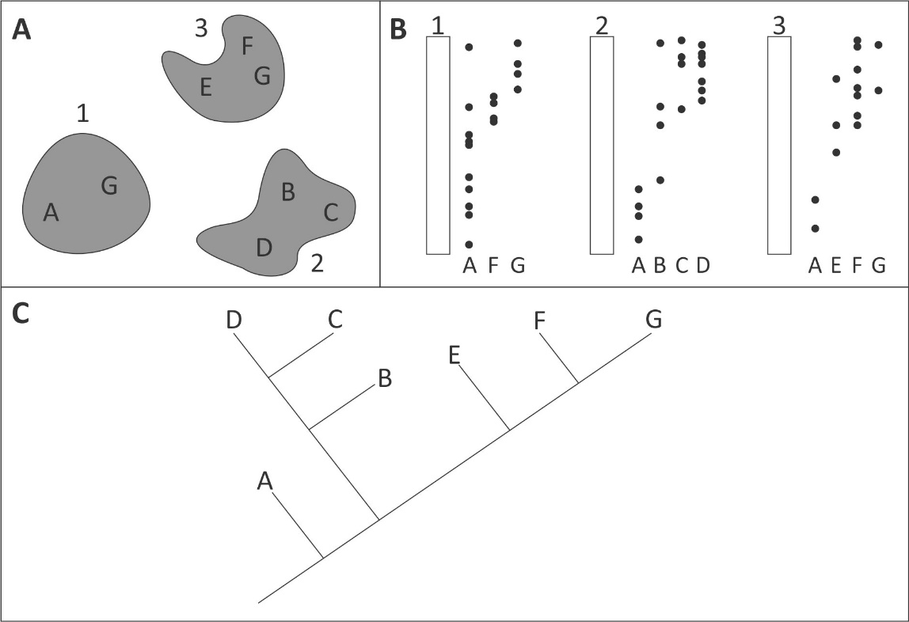
Fig. 2. A: Locality map showing position of three geographic regions (1, 2, and 3) and their present-day species composition (species A-G). B: Stratigraphic columns for the three regions indicating the recorded stratigraphic positions of species A-G in each region. C: Cladogram illustrating the evolutionary relationships of species A-G.

2. List one evolutionary event characterized by vicariance and explain the evidence that supports your conclusion.

3. List one evolutionary event characterized by dispersal and explain the evidence that supports your conclusion.

Using the cladogram illustrated in figure 3 and the data file biogeog_data at eCommons to answer questions 4-6.

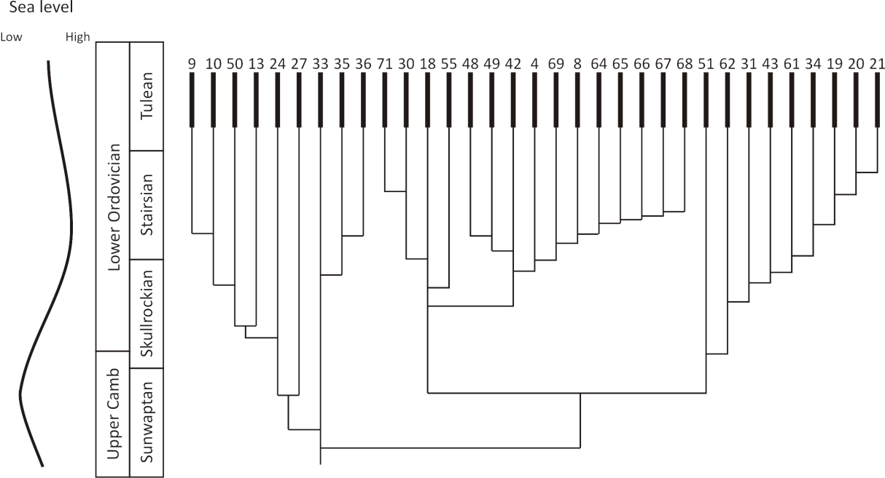
Fig. 3. Cladogram of selected trilobite species (see biogeog_data file at eCommons for information on species ID numbers), showing time of divergence relative to the North American Cambrian-Ordovician timescale. A relative sea-level curve is shown to the left, from low sea level (left side) to high sea level (right side).

4. Was the evolutionary divergence between the clade containing species 18 and its descendants and the clade containing species 51 and its descendants driven by vicariance or dispersal? The trilobite species info spreadsheet (in the in-class exercise folder at eCommons) indicates whether the species lived on the eastern, western, or on both sides of the Transcontinental arch. Explain your reasoning.

5. Identify two clades whose evolutionary divergence was driven by dispersal, and explain how you made that conclusion.

6. What is the relationship between vicariance/dispersal events and the relative sea level curve? Explain why this relationship exists in the case of the Transcontinental Arch.

