Earth 101: Heterochrony Assignment Name ________________________

For this assignment, you should identify one of the six specific cases of heterochrony, not just paedomorphosis or peramorphosis.

Question 1

The following figure shows the pattern of shape change during ontogeny of the bivalve Gryphaea arcuata, from the early juvenile (A) to late juvenile (B) to adult (C). Note the magnification factors of the juvenile stages.

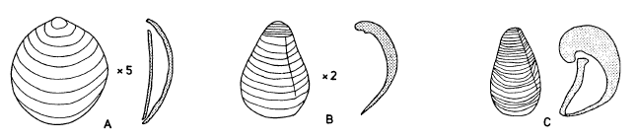

Here are adults of Gryphaea mccullochi (D) and Gryphaea gigantea (E). They are shown at x1.
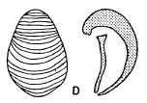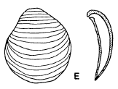

Assuming that Gryphaea arcuata represents the ancestor, what type of heterochrony is most likely responsible for evolution of these two species? Which species has undergone a greater degree of heterochrony?

Question 2

The following figure shows the ontogeny of the trilobite Olenellus lapworthi (thin vertical arrow on left) and the evolutionary relationship of five species of Olenellus (large diagonal arrow). What type of heterochrony is represented?

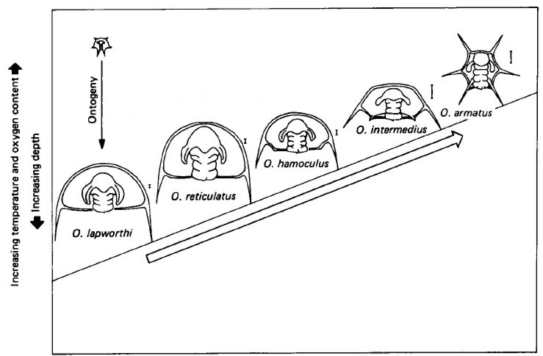

Question 3

This question centers on the evolution of the irregular echinoid Eurhodia rugosa (D-F) from Rhyncholampas carolinensis (A-C). Both are middle Eocene in age.

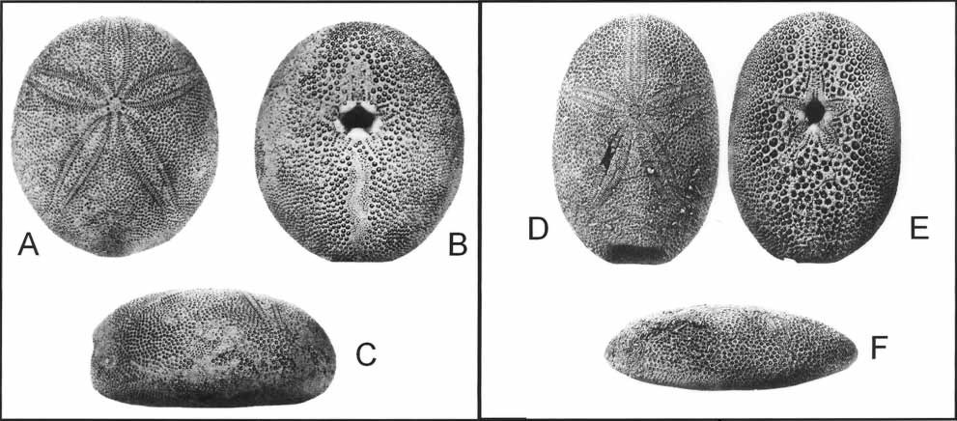

In previous examples, we have considered whether an entire organism is paedomorphic or peramorphic; however, it is actually characters that undergo heterochrony. Organisms have multiple characters, which can evolve independently via different heterochronic mechanisms. Some of the characters and their abbreviations are illustrated below. You do not need to know the details of the characters.

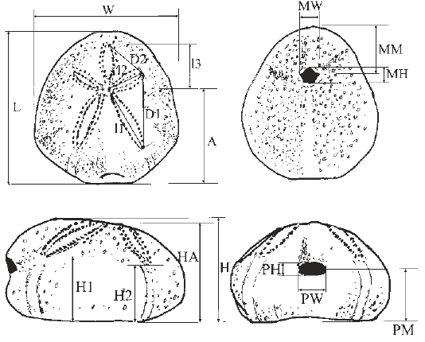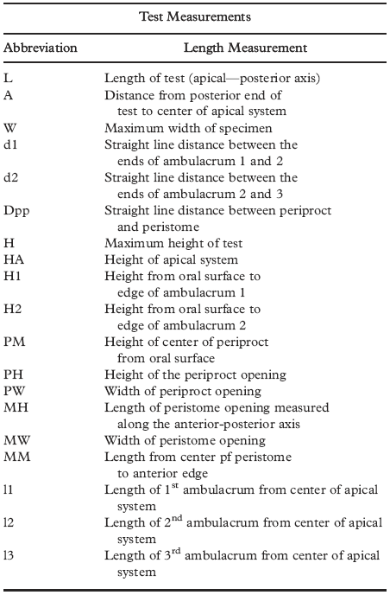
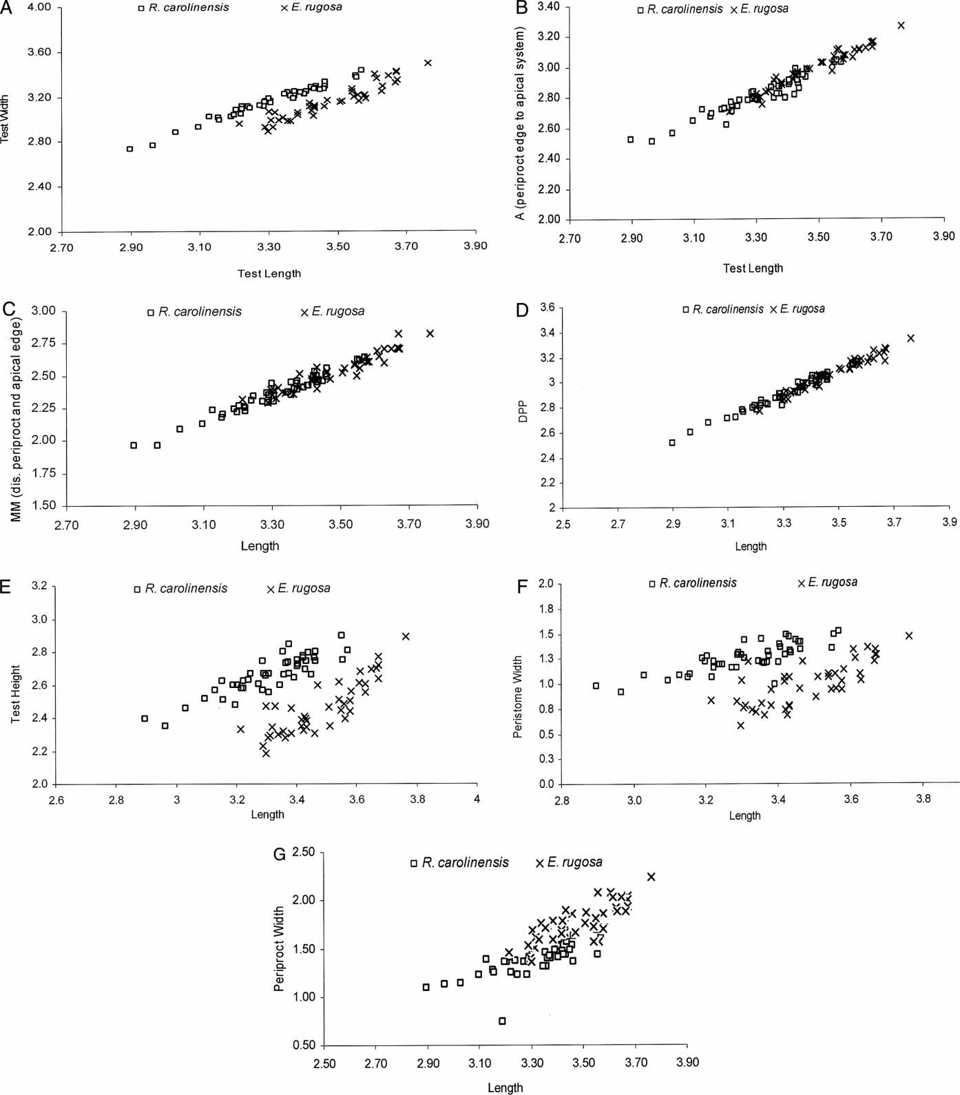

Using the data in graphs A-G, determine the type of heterochrony in each character.
Body Part | Type of Heterochrony
Test width (W)
A
MM
Dpp
Test height (H)
Peristome width (MW)
Periproct width (PW)

