EART101: Guilds and evolutionary faunas Name: _______________________

Evolutionary faunas

Evolutionary faunas are the largest scale of taxonomic organization in the marine realm, typically featuring shifts in the diversity and abundance of higher-level taxonomic groups like phyla or classes.

Look at the diversity plots for 12 marine invertebrate groups (EF diversity plots file in the In-class exercise folder at eCommons) and categorize the groups into “evolutionary faunas” on the basis of their shared diversity history. You can divide them into as many or as few faunas as you think are justified.

1. List each evolutionary fauna you created and the groups it contains. Why did you put each group into a particular fauna?

2. Are there any ecological similarities (life habit, feeding strategy, shell mineralogy, etc.) among the groups in a particular evolutionary fauna?

3. When did the transitions between your evolutionary faunas occur?

Ecological-Evolutionary Units

While evolutionary faunas are characterized by stability among the highest taxonomic levels in the ecosystem, ecological changes still occurred at lower taxonomic levels within those intervals. Intervals of stability at intermediate taxonomic levels (order or family level) have been called Ecological-Evolutionary Units, and occur over intermediate timescales.

Examine the graph of brachiopods abundance (Brach_EEU at eCommons). It shows the proportional abundance of six different brachiopod orders from the Ordovician through the Permian.

4. How would you use changing abundance of the brachiopod orders to divide this time interval into Ecological-Evolutionary Units? Which orders characterize each EEU? When did the transitions between EEUs occur?

Guilds

Organisms can be grouped into “guilds” on the basis of ecological attributes like life habit, feeding, and motility. The ecological guild structure of marine communities has changed dramatically over the course of the Phanerozoic. Use the following graph to answer the questions.

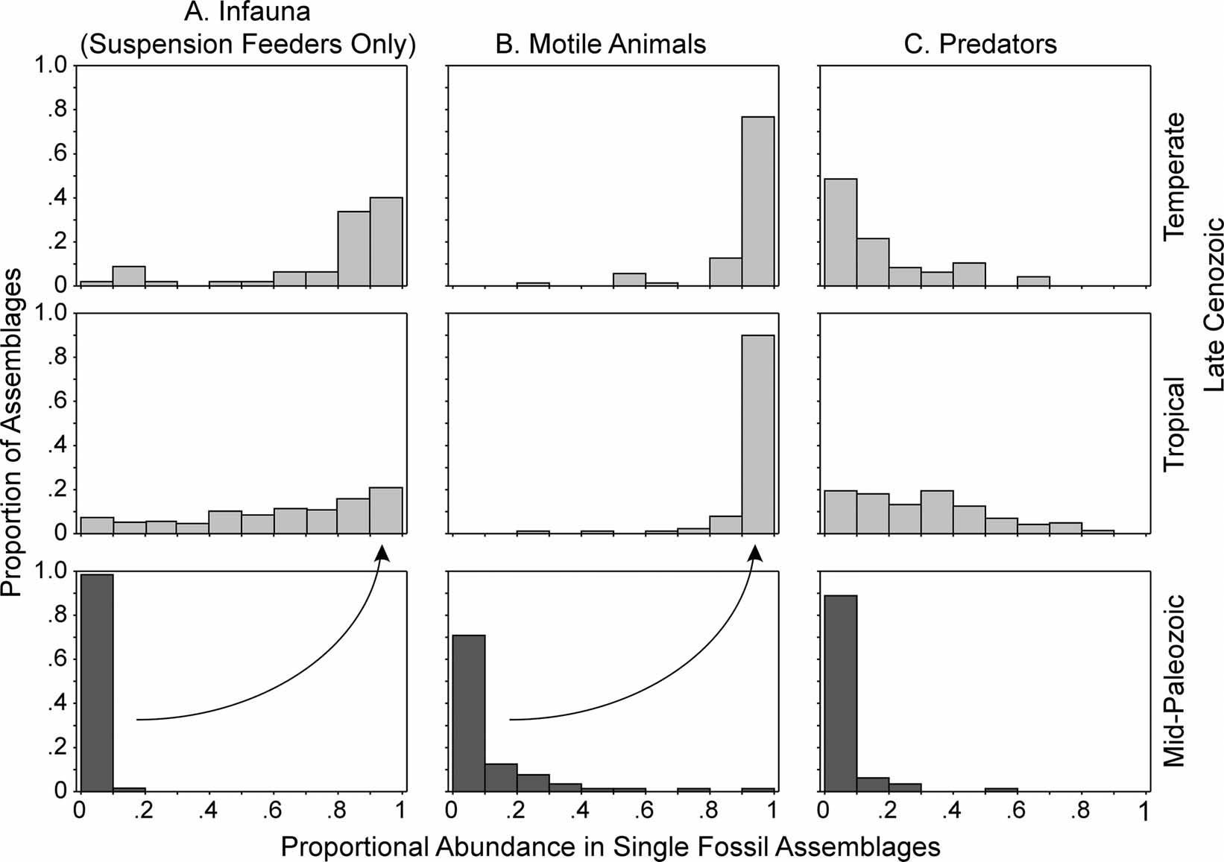
Fig. 1. Graphs showing the proportion of fossil assemblages containing a given range of (A) infauna, (B) motile animals, and (C) predators. For example, nearly 100% of mid-Paleozoic communities contained between 0 and 10% infauna.

5. How did the abundance of a) infauna, b) motile animals, and c) predators shift from mid-Paleozoic to Late Cenozoic communities?

6. What are two potential explanations for that shift in the abundance of infauna? One can be determined from data in the graphs themselves. For the other, think about what you learned in the substrate adaptations lecture.

