Earth 101: Evolutionary trends exercise Name: ________________________

The fossil record contains many examples where size, shape, or some other aspect of morphology changed over time within a species or within an evolving lineage of related species. It is tempting to interpret those changes as a directional trend driven by natural selection, but remember that random fluctuations, especially bounded random walks that impose a constraint on size or shape, can also result in apparent trends. This exercise compares random walks and driven trends.

Part 1: Bounded random walk simulation

Flip the coin ten times and keep a running tally of the score. The score starts at zero; add one to the score each time the coin lands on heads, and subtract one from the score each time the coin lands on tails. There is one important constraint: the score can never fall below zero. Therefore, if the current score is zero and the coin lands on tails, the score will remain at zero in the next step.

Enter your data in the table below and in the appropriate row of the “coin flip data” spreadsheet online (link at eCommons in the In-class exercises folder).

Start | 1 | 2 | 3 | 4 | 5 | 6 | 7 | 8 | 9 | 10
0

Open the file evol_trends.R in RStudio. While you wait for everyone to enter their coin flip data, run step 1 to install and load required packages.

Once everyone has entered the coin flip results, run step 2 to read the data and step 3 to plot a graph showing each trial (gray lines) and the average value at each step (red line).

1. How do the minimum, average, and maximum values change over time? (Don’t describe every step, try to generalize the overall trajectory).

2. Coin flips generate a random walk because heads and tails are equally likely outcomes. Describe how your results from question 1 indicate that the system evolved by a random walk rather than by a directional driven trend.

Part 2: Bryozoan zooid size and temperature

The size of bryozoan zooids exhibits an inverse relationship with temperature: zooids are smaller when temperatures are warmer. The following (hypothetical) data (Fig. 1) come from fossil bryozoans on the Caribbean coast of Panama. The Panama isthmus formed in the Pliocene epoch, separating the Caribbean side from cooler Pacific Ocean water. As a result, temperatures in the Caribbean became warmer and less seasonally variable from the Late Miocene to today.

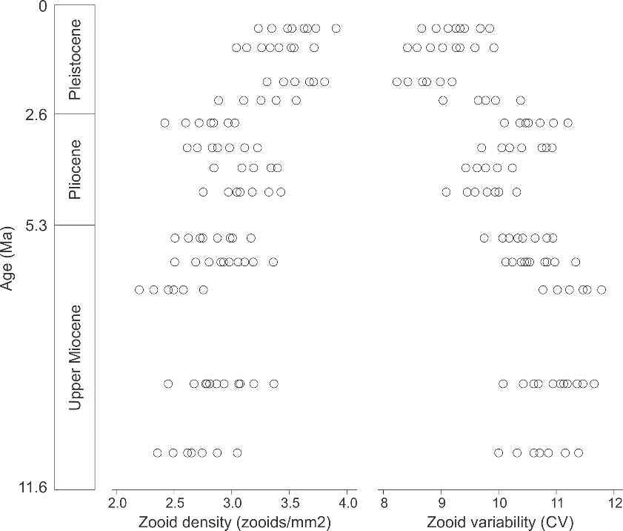
Fig. 1. Zooid density and zooid size variability for Neogene fossil bryozoans from the Caribbean coast of Panama.

3. Are the bryozoan data consistent with a directional driven trend towards smaller zooid sizes (greater zooid density) and/or less variable zooid size (lower coefficient of variation, or CV) or are they more consistent with a random walk? Zooid density and zooid variability do not have to follow the same type of trend. Justify your answer.

Part 3: Cambrian echinoderms and substrate

Many echinoderms are sessile epifauna and, as such, they are susceptible to changes in the nature of the substrate. The Cambrian was a time of increasing bioturbation as infaunal organisms diversified, resulting in a major shift from firm to softer substrates (called the “Cambrian Substrate Revolution”). Edrioasteroid echinoderms have fringing rows of plates, such as the small plates in a ring around the edge (Fig. 2), which are thought to be adaptations for cementing to hard surfaces like shells or rock (one possible lifestyle when substrates are soft). Specimens that lacked fringing plates rested on firm substrates.

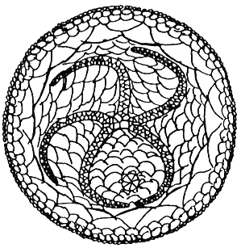
Fig. 2. Oral view of an edrioasteroid, showing fringing plates used in hard-substrate attachment.
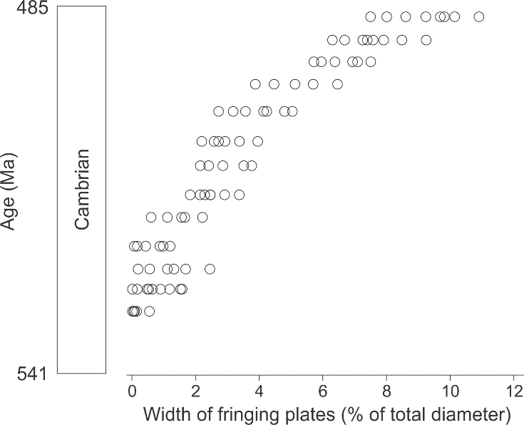
Fig. 3. Width of edrioasteroid fringing plates in Cambrian specimens.

4. Based on the data in figure 3, did edrioasteroids show a directional, driven trend towards increased fringing plate width (indicative of a lifestyle shift from firm to hard substrate attachment), or are the data consistent with a random walk? Justify your answer.

Part 4: Long-term size trends

Figure 4 shows the trend in maximum body size over the history of life on Earth. Each point represents the largest known organism at a given time in Earth history, from bacteria in the Archean to vertebrates in the Phanerozoic. Note that adjacent points do not reflect ancestor-descendant pairs.
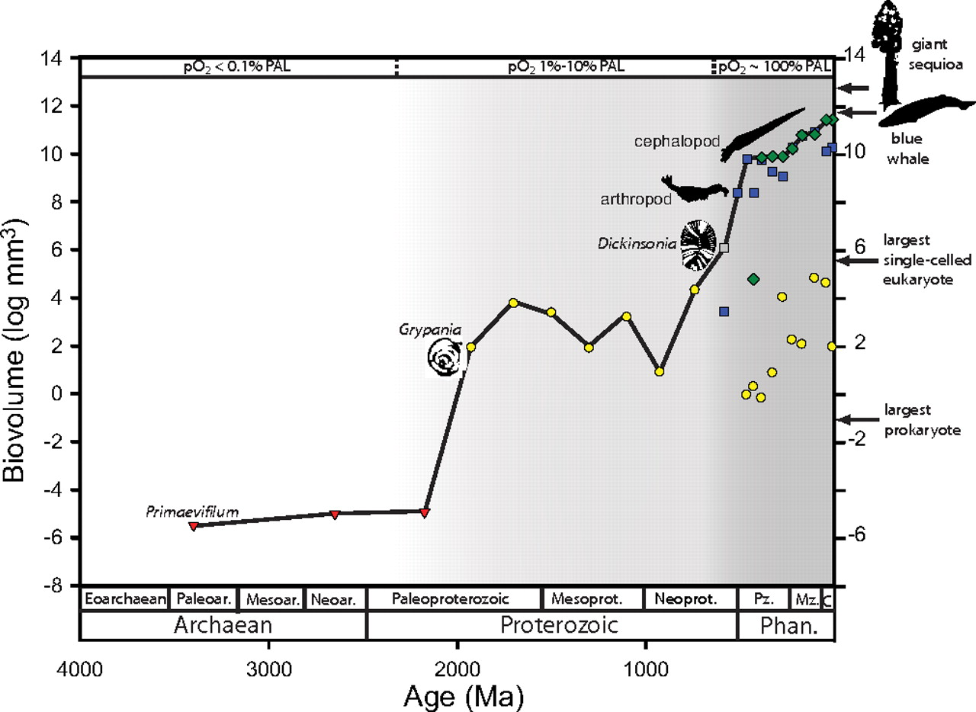
Fig. 4. Size of the largest organisms over the history of life. Adjacent points are not ancestor-descendant pairs.
5. Do you think that the pattern of increasing maximum body size over time is a bounded random walk or a directional, driven trend? Why?

Part 5: Model comparison

In reality, trends in size or morphology rarely correspond exactly to a random walk, driven trend, or to stasis. Assessing trends actually requires statistical methods (“maximum likelihood analysis”) to determine the best fit. You don’t need to know about those methods, but this section applies the tests to a few datasets so you can see how this type of analysis would really be done.

Dataset 1 includes measurements of denticle spacing and denticle height from conodont elements (Fig. 6). Dataset 2 includes counts of the number of chambers per individual and the width of the aperture in planktonic foraminifera (Fig. 7). Those datasets were originally interpreted as examples of phyletic gradualism.

Fig. 6. Conodont element showing denticles (serrations in lateral view, right) and height of the largest denticle (Hb)

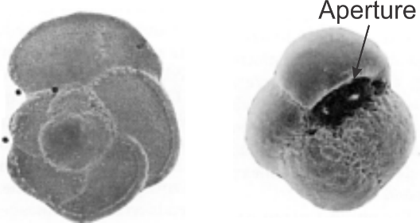
Fig. 7. Planktonic foraminifera specimens, composed of multiple chambers with an aperture.

In RStudio, run step 4 to load the conodont and foram datasets.

Run steps 5-8. For each step, examine the graph and determine qualitatively whether the trend looks like a random walk, driven trend, or stasis. The last command of each step will output the maximum likelihood results; of all of the statistics, you only need to note the Akaike weights in the right column. They sum to 1 and indicate the proportion of support assigned to each model (GRW is directional evolution, URW is an unbiased random walk, and stasis is obviously stasis). The model with the highest Akaike weights is the best explanation of the data.

6. All four datasets were originally interpreted as evidence for phyletic gradualism (a directional, driven trend). What do the statistical results say about each?

