EART101: Diversity Name: _______________________

The fossil record is the only source of information on the history of diversity on Earth and can be used to reconstruct diversification trends and evaluate potential controls on global diversity. However, quantifying diversity from the fossil record can challenging because there are biases that must be addressed.

The following figure shows the fossil records of 13 species (A-M) in fifteen time intervals (1-15). Circles indicate that the species was actually discovered as fossils in that time interval and blank spaces are time intervals when it was not found.

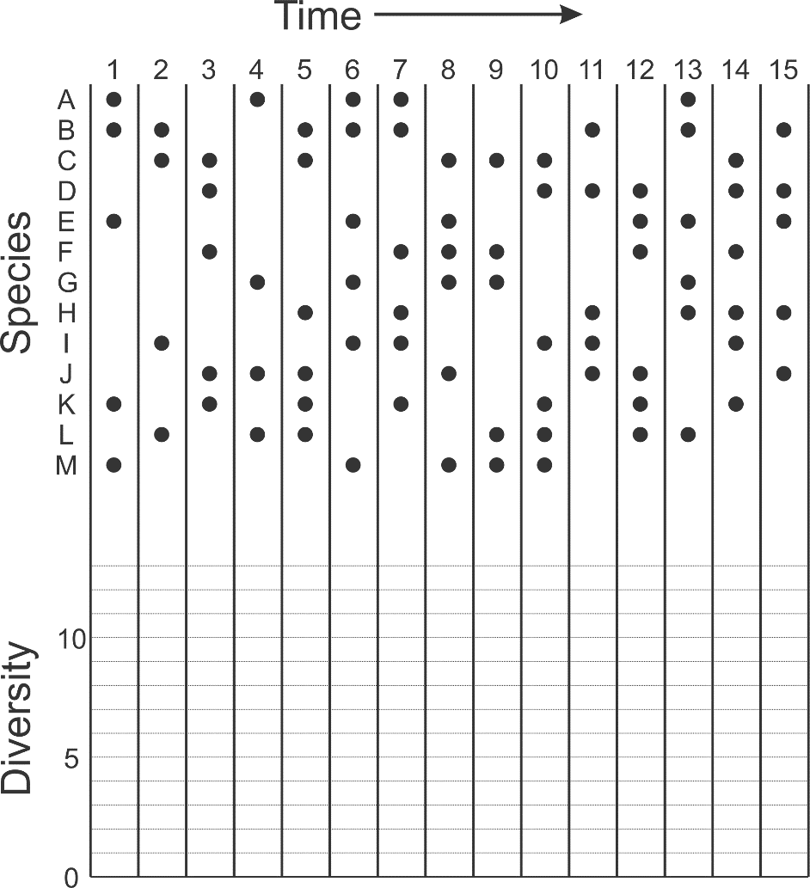

1. Construct diversity curves from the ranges of species A-M. Draw diversity using the sampled-in-bin counting method (as a solid line) and using the range-through counting method (as a dashed line).

2. How do your two curves differ? What causes that difference?

3. Which of your two curves is a better representation of overall diversity trends and why?

4. How should abundance of a fossil group affect the magnitude of the edge effect observed in range-through curves?
This figure shows the diversity of ostracods in the Late Permian at the Meishan section in south China. The solid line indicates the number of species per sample; the dashed line indicates the number of individual ostracod specimens recovered per sample. The authors interpreted the diversity curve to reflect five diversity peaks (P1-P5) and four diversity lows (D1-D4), which they attempted to correlate with sea level. They also argued that the main ostracod extinction (OME) preceded the end-Permian mass extinction (at bed 24).

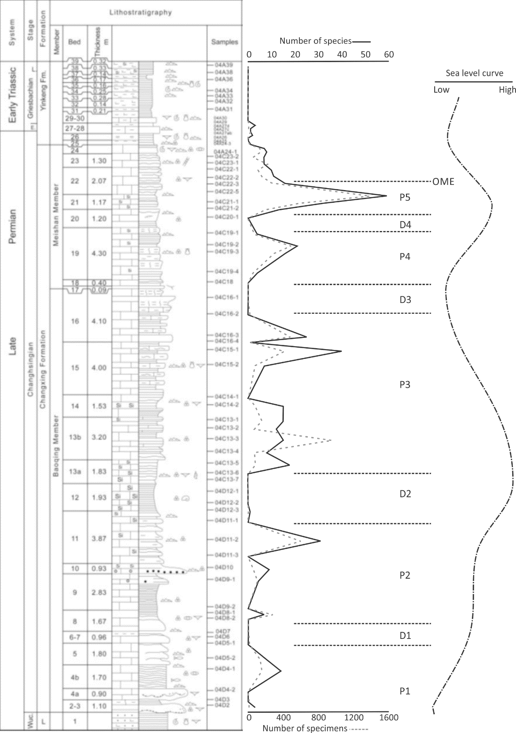

5. Do you think that the diversity peaks and lows reflect true biological differences in diversity? Why or why not? What does that mean about the relationship between diversity and sea level?
Paleontologists have attempted to deal with all of the biases affecting fossil diversity by devising increasingly sophisticated statistical techniques for subsampling standardization. The details aren’t important, but this is a recent diversity curve for Phanerozoic marine invertebrates:
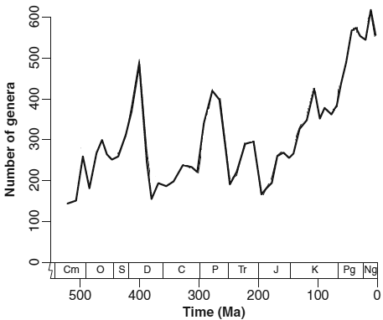

The following graphs illustrate trends in the proportion of fossil occurrences from carbonate sediments (A), the proportion of fossil occurrences from reefs (B), and the number of geographic regions that contain fossil samples (C). The data for panel C was created by dividing the globe into equal-area regions (or cells) based on latitude and longitude, and counting the number of cells that contained at least one fossil occurrence. The thick line is based on global data and the thin line is based on data just from the tropics.

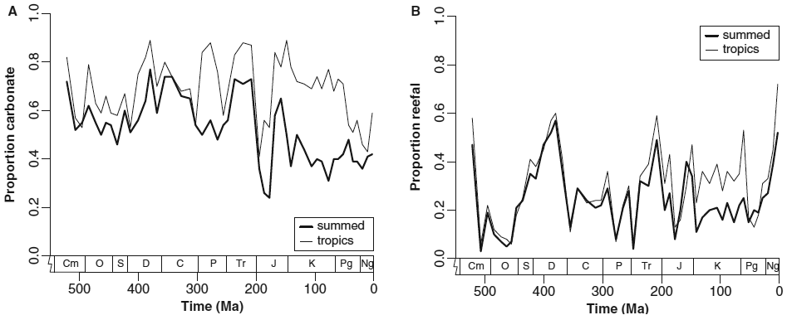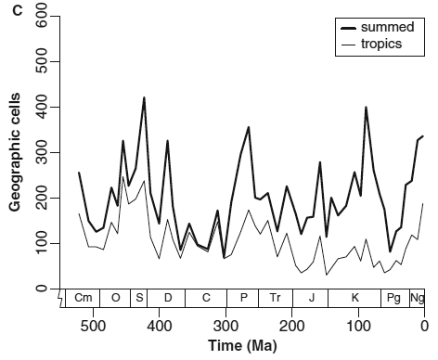

6. Compare the diversity trends to patterns of carbonate occurrences, reef occurrences, and geographic scope of sampling. What relationship, if any, is there between diversity trends and those environmental or geographic factors? Why might those relationships exist? This question is fairly open-ended and there isn’t a single correct answer; you can bring together any information from this class or others to make plausible arguments.

