Earth 101 –Cladistics Exercise

Write your answers on a separate sheet and turn them in at the end of class. You may want to work on a rough draft of the cladogram (in part 3) before writing a clean, final version on your answers.

Part 1. Examine the following cladogram and answer the questions.

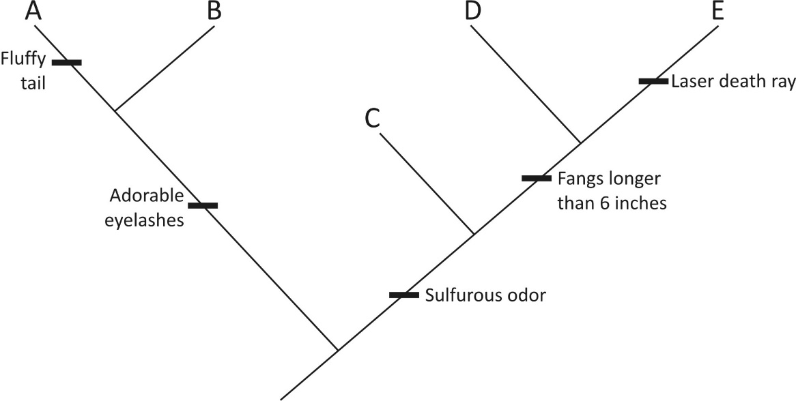

- What is the synapomorphy of the clade containing species D and E?

- What is a plesiomorphic character of that clade?

- What is the synapomorphy of the clade containing species A and B?

- Which taxa have a sulfurous odor?

- What character distinguishes species D from species E?

- Are adorable eyelashes a synapomorphy or an autapomorphy?

Part 2. Use the previous cladogram to answer the questions.

- Traditionally, the five taxa are grouped into three families. Family 1 contains species A. Family 2 contains species B and C. Family 3 contains species D and E. Determine if each family is monophyletic, paraphyletic, or polyphyletic.

- More recently, species A has been grouped in a family with species D and E. Is this advisable? Why or why not?

- Determine if the following groups are monophyletic, paraphyletic, or polyphyletic. Species A, B, C. Species C, D, E. Species C and D. Species A and B. Species B, D, E.

Part 3. Use the data matrix to construct the most parsimonious cladogram for the eight species. Species 1 (Sp 1) is the outgroup taxon.
 | Sp 1 | Sp 2 | Sp 3 | Sp 4 | Sp 5 | Sp 6 | Sp 7 | Sp 8
Circle (0)/Square (1) | 0 | 0 | 0 | 1 | 0 | 1 | 1 | 0
Central circle | 0 | 1 | 0 | 0 | 1 | 0 | 0 | 0
Side lobe | 0 | 1 | 0 | 1 | 0 | 0 | 1 | 0
Triangle spines | 0 | 0 | 1 | 0 | 0 | 1 | 1 | 1
Blue (0)/Yellow (1) color | 0 | 0 | 0 | 1 | 0 | 1 | 1 | 1
Central diamond | 0 | 0 | 0 | 1 | 0 | 0 | 0 | 0

- What is the synapomorphy of the clade defined by the most recent common ancestor of species 4 and 8 and all of its descendants?

- List the apomorphies that distinguish species 4 from all other species.

- What is the synapomorphy of the clade defined by the most recent common ancestor of species 6 and 7 and all of its descendants?

- List the plesiomorphic characters found in the clade defined by the most recent common ancestor of species 3 and 4.

- What traits would you predict in the common ancestor of species 4 and 6?

- What character evolved independently in different clades (convergent evolution)?

- Is the group of taxa sharing the character “triangle spines” monophyletic, paraphyletic, or polyphyletic?

