EART101: Biogeography exercise Name ______________________________

The Cordilleran belt of western North America is composed of a collage of exotic terranes, microcontinental blocks that originated as island arcs in the Pacific and later were accreted to the continental margin. You would like to know the location of these terranes in the past. The table below contains presence/absence data for Early Jurassic ammonite species from three accreted terranes (Wrangellia W, Stikinia S, and Quesnellia Q) and from the North American continent (Boreal Craton BC and Sonomia So). The Boreal Craton represents higher-latitude, cooler-water faunas and Sonomia contained lower-latitude, warmer-water faunas.

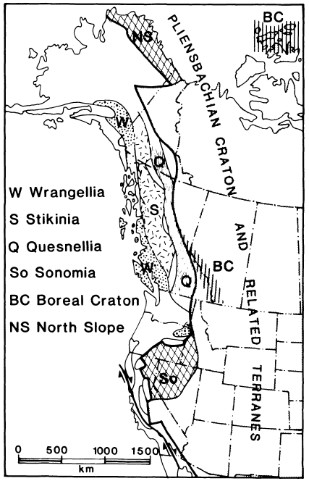 |  | W | S | Q | BC | So
 | Amaltheus | X | X | X | X
 | Pleuroceras |  |  |  | X
 | Pseudoamaltheus |  |  |  | X
 | Becheiceras | X | X
 | Arieticeras | X | X | X |  | X
 | Fontanelliceras | X
 | Fuciniceras | X | X | X
 | Leptaleoceras | X | X
 | Lioceratoides | X | X |  |  | X
 | Protogrammoceras | X | X | X | X | X
 | Aveyroniceras | X | X |  |  | X
 | Prodactylioceras | X | X |  |  | X
 | Reynesoceras | X |  | X
 | Cymbites | X
 | Fanninoceras | X | X | X |  | X
 | Phylloceras | X

1. Calculate Jaccard similarity coefficients between each of the accreted terranes (W, S, and Q), and between the terranes and the two stable continent regions BC and So. The Jaccard coefficient is M/(N1+N2-M), where M is the number of taxa shared between the two regions, N1 is the number of taxa in region 1, and N2 is the number of taxa in region 2. Fill in your answers in the table below.

 | W | S | Q | BC | So
W
S
Q
BC
So

2. For each terrane, determine its approximate paleolatitude in the Early Jurassic. Was it located at lower latitudes (similar to Sonomia) or at higher latitudes (similar to the Boreal Craton)?

3. Compare the similarity coefficients among the three terranes and discuss their relative positions based on the faunal results. Which were closer to each other in the Jurassic?

The next section focuses on the biogeography of Early Ordovician trilobites from nine North American localities, four on the western side of the Transcontinental Arch (Alberta, Montana, Utah-North, Utah-Ibex) and five on the eastern side (Texas, Oklahoma, Missouri, Pennsylvania, Newfoundland). The Transcontinental Arch was a raised tectonic feature that separated the western and eastern basins during certain times in the early Paleozoic. At other times, the Transcontinental Arch was submerged, allowing species from one side to migrate to the other.

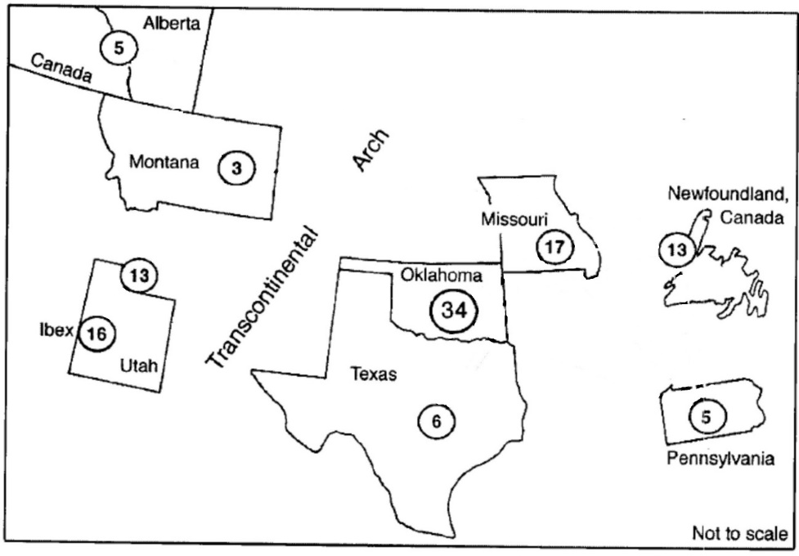
Fig. 1. Schematic map of Early Ordovician North America, showing the position of the Transcontinental Arch and the nine sampling areas. Each sampling area is shown by a circle, and the number within each circle indicates the number of trilobite species recorded at that location.

Use RStudio to run biogeog.R and generate a cluster dendrogram of faunal similarity.

4. Based on your results, was the Transcontinental Arch an important barrier in the Early Ordovician? Explain your reasoning.

5. Biogeographic analysis is based on the premise that geographic distance should be a primary control on the faunal similarity of the sites. However, these trilobite samples come from only one or a few collections from each region. Given that, what other factors may also have influenced the observed similarity values among the sites?

6. Based on your results, were there significant biogeographic differences within the region west of the Transcontinental Arch (Alberta, Montana, Utah-North, Utah-Ibex)? Explain your reasoning.

