EART101: SPECIES CLASSIFICATION Name: _____________________
Nov. 3, 2014

Fossil species are recognized and classified on the basis of morphology because other lines of evidence (such as interbreeding or genetics, used with living organisms) are not available. This can introduce subjectivity into the process of classification; all species display some range of morphological variability and the line between intra- and interspecific variability is often a judgment call. Further complications can be introduced by morphological changes during ontogeny (growth from juvenile to adult) and because of sexual dimorphism (different male and female morphology).

1. Open the Ammonoid pictures file at eCommons (in the “In-class exercises” folder of Resources). It contains illustrations of 25 ammonoid specimens that you should group into species, keeping in mind the potential for intraspecific variability, ontogenetic change, and sexual dimorphism.

2. Open the ammon_classify.R file in RStudio. It loads a data file containing shell coiling measurements traditionally used in ammonoid classification (Fig. 1), including diameter (D), the ratio of umbilical width U to diameter (U/D), and the ratio of shell width W to diameter (W/D). The file also contains the stratigraphic position of each specimen. Follow the instructions in the R file to classify the specimens and make graphs (remember that intraspecific variability often follows a normal distribution, or a bell-shaped curve).

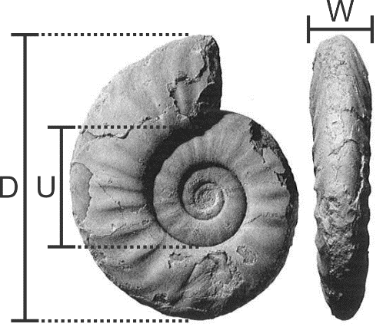
Figure 1. Ammonoid shell with diameter (D), umbilical diameter (U), and width (W) measurements.

Your assignment: Write a short summary of your conclusions, including
1) Your identifications (how many species do you recognize in the group, and which specimens belong to which species)
2) The morphological features you used to distinguish each species, including whatever combination of qualitative and quantitative traits you think are important
3) The nature of ontogenetic change, if any, in the species
4) The possibility of sexual dimorphism as a cause of morphological differences and how you evaluated that possibility (the illustrations and data contain enough information for you to assess sexual dimorphism).

As with all writing, be organized and precise!

