EART101: Biostratigraphy Exercise Name: _______________________

Biostratigraphy has been one of paleontology’s most important contributions because it allows subdivision and correlation of the rock record. Recognition and correlation of zones are based on the first appearance of index fossils; this exercise will get you to consider biases affecting first appearances and characteristics of good index fossils.

Load the file firstAppearances.R (from the in-class exercises folder of eCommons resources) in RStudio. It will plot the true and observed ranges of ten fossil species at a hypothetical sedimentary succession that ranges from deeper water at its base to shallower water at the top. Read the description of the program and then run step 1.

- Edit the abundance value in step 2 (initially set at 100) to investigate how abundance of a species influences recognition of its true first appearance. You should run the commands from step 2 and step 3 each time you edit the abundance value. The numbers are relative, but a value of 10 corresponds to a rare species, whereas 100 represents a very common species. Try a few different abundance values between 10 and 100, and then summarize your findings.

How and why does abundance of a species bias recognition of the true first appearance?

- Set the abundance value to 20 and vary the preferred_depth and depth_tolerance values in step 2. Re-run all commands in steps 2 and 3 each time you edit preferred_depth or depth_tolerance. Preferred depth can vary from 0.1 (deep water preference) to 0.9 (shallow water preference). Depth tolerance can vary from 0.05 (narrow depth range, i.e. stenotopic) to 0.5 (wide depth range, i.e. eurytopic). Try a few different combinations and then summarize your findings.

How and why do facies preferences of a species bias recognition of the true first appearance at this location?

General questions about index fossils:

- Many index fossil groups are planktonic or nektonic: e.g., ammonites, graptolites, conodonts, planktonic foraminifera, radiolarians, or calcareous nannoplankton. Why are planktonic/nektonic groups often good index fossils?

- Many index fossil groups are also microfossils: e.g., conodonts, planktonic foraminifera, radiolarians, or calcareous nannoplankton. Why would microfossils be good index fossils?

Examine figure 1 before answering the next question. It illustrates the stratigraphic ranges of species belonging to four Cambrian fossil groups. The sedimentary succession is composed of alternating limestone (brick pattern) and sandstone (stippled pattern).

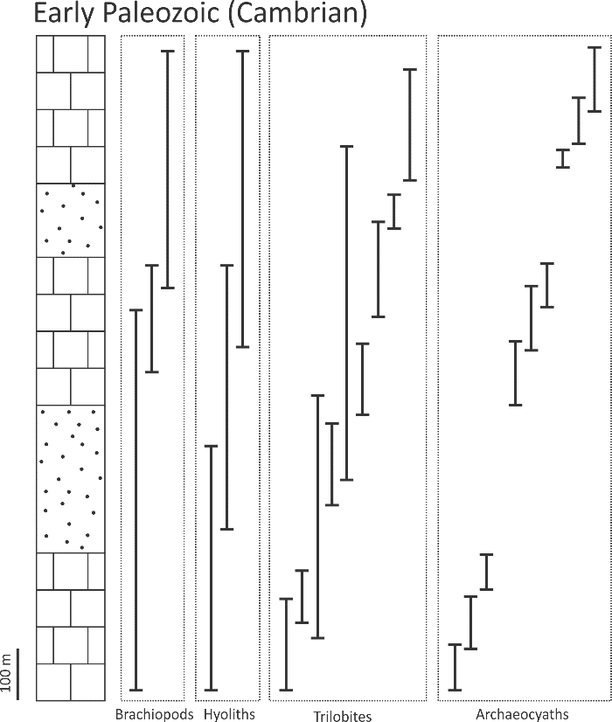
Fig. 1. Stratigraphic ranges of brachiopod, hyolith, trilobite, and archeocyath species in a Cambrian succession.

- Which of the four taxonomic groups illustrated in figure 1 would be the best choice for index fossils? Explain why and contrast with the other groups.

